**TRAINING REPORT**

**ON**

**CMC-SCHNEIDER ACCOUNT MANAGEMENT PORTAL IN ASP.NET**

A Project submitted in fulfillment of the requirement for the award of

**BACHELOR OF TECHNOLOGY**

IN

**COMPUTER SCIENCE ENGINEERING**

BY

**SAURABH RAO**

**(1210312512)**

**GITAM INSTITUTE OF TECHNOLOGY**

**GITAM UNIVERSITY**

**VISAKHAPATNAM – 530045.**

**(2012-2016)**

**DEPARTMENT OF COMPUTER SCIENCE & ENGINEERING**



**CERTIFICATE**

This is to certify that the training report is a bonafide record of work carried out by SAURABH RAO (1210312512) student of Bachelor of Computer Science and Engineering, GITAM UNIVERSITY, Rushikonda, Visakhapatnam during the year 2013-2014,submitted for fulfillment of Bachelor Degree of Department of Computer Science & Engineering.

Dr.P.V.Nageswara Rao,

Professor and Head of Department of CSE

GIT, GITAM UNIVERSITY

Visakhapatnam.

**DECLARATION**

I hereby declare that the project work entitled “**CMC-Schneider Account Management Portal**” is an authentic record of my own work carried out during the project based industrial training at “**CMC Ltd.** This project is submitted to the Department of COMPUTER SCIENCE AND ENGINEERING in GITAM INSTITUTE OF TECHNOLOGY, VISAKHAPATNAM.

SAURABH RAO

1210312512

**ACKNOWLEDGEMENT**

I could successfully complete project that was assigned to me in the desired timeframe due to the involvement of many people. Firstly, I would like to express my sincere thanks to **Mr. Sunil Katcharala, Senior Manager**  for permitting me to undergo my training at CMC Limited , Hyderabad. I am also thankful to **Mr.Youvraj Kakade** for mentoring me and helping me with the various aspects of the project.

I could achieve this project with the continuous encouragement and support given by the officials who assigned the Project. I consider it as our privilege to express our gratitude and respect to all officials who guided, inspired and helped to complete the Project work in time.

**ABSTRACT**

The industrial training at CMC Ltd was a useful experience of working with a company in a professional environment. On the first day of the training, I had a short, informal interview to decide what group I would work in. Taking my expression of interest and knowledge, I was assigned to develop a web application in asp.net .I had the opportunity to work on something that I had never dealt with before , something which was challenging yet rewarding at the same time. I was given time to understand the basic functionality of the web application project. I spent the first few days getting acquainted with the different concepts through which I was thoroughly helped out by Mr.Kakade. After getting familiar with Visual Studio 2013 and spending sometime completing a few tutorials and courses,, I started working on the web application in full swing. Throughout the training session, I improved on my coding skills and got a tremendous practical orientation of work, as I was developing an application that was going to be used practically. It was important to stick to the constraints that were mentioned by Mr.Katcharala, as this was an internal company application. I was also fortunate enough to be guided by my mentor and manager in all respects , right from understanding the basic concepts to clarifying my doubts. The company had an amicable environment, maintaining its professionalism at the same time, and did permit me to know more about the work going on in the other groups. By the end of my training, I had designed the basic functionality of the application and had also worked on a major part of the front end , as per the instructions that were assigned to me.

**CONTENTS**

1. Organization profile
2. Project description
3. Languages and Frameworks used
4. ASP.NET
5. MVC Architecture
6. C#
7. Bootstrap
8. HTML
9. CSS
10. Javascript
11. Antlr
12. iTextSharp
13. jQuery
14. JSON.NET
15. Entity Framework
16. Microsoft OWIN
17. Respond.JS
18. Modernizr
19. WebGrease
20. pagedlist.MVC
21. IDE Used
22. Visual Studio 2013
23. Code First approach
24. LocalDB
25. Scaffolding
26. Creating a project
27. Requirements
28. Software requirements
29. Hardware requirements
30. Supported operating systems
31. Supported architectures
32. CMC-Schneider Account Management portal in asp.NET
    1. Screenshots and explanation
33. Conclusion

**PROJECT TRAINING AT CMC LIMITED, HYDERABAD**

**Organization profile:**



CMC Limited is a leading systems engineering and integration company in India, offering application design, development, testing services and asset-based solutions in niche segments through turnkey projects of national importance. CMC has also been expanding its service presence in international markets offering off-shoring advantages and delivering value through service level-based and project scope-based deliveries. Since its inception on December 26, 1975, CMC has been a frontrunner in providing IT solutions and services. CMC was the first ever enterprise in India to set up a countrywide data network called INDONET - a computer network providing access to major cities in India, way back in 1985.  
 A subsidiary of Tata Consultancy Services Limited ([**TCS**](http://www.tcs.com/) Ltd), one of the world's leading information technology consulting, services and business process outsourcing organizations, CMC Limited is a part of the US$ 100.09 billion Tata Group, India's best known business conglomerate.Today, CMC Limited, an ISO 9001:2000, certified and CMMI Level V accredited organization, is positioned as a premier IT solutions provider in the fast growing and competitive IT market. They have execute large and complex turnkey projects, and have built, managed and supported IT systems across the value chain infrastructure, applications and business processes.

CMC has 18 offices in major Indian cities and over 150 service locations. They have a sizable resource pool of engineers trained in diverse technologies, with vast domain knowledge and varied skill sets. CMC's products for transport, law enforcement, banking and insurance verticals, and services in embedded technologies, IT Consultancy and Infrastructure Development Management and Outsourcing are offered through this office.They are committed to creating value for customers through their Information Technology services and products, and they assure this through the quality systems that we have built into the organization. CMC subscribes to the Business Excellence philosophy and a Quality Management System in line with ISO 9001:2008, CMMI, PCMM and SPICE.

**PROJECT DESCRIPTION**

The project titled **“CMC-Schneider Account Management portal in asp.NET ”** is a web application. The application will potentially be used as an internal account management system for CMC-Schneider. Later on , the application will also be taken over by other zones in the SEZ and replicated throughout the company after the required customizations are made. The asp.net web application is done in Visul Studio 2013, Microsoft’s flagship integrated development environment and also uses various concepts like Code First Architecture, Scaffolding, MVC Architecture , Entity Framework and LocalDB , to name a few. The entire web application is responsive, as the bootstrap framework is being used , along with Javascript, apart from the standard HTML5 and CSS. Visual C# has been used to code the entire project.   
  
These are three main features in the project :   
1. The administration segment consists of Contracts, Projects and Employees and Jobs. Each of these Each project is unique and is identified by the WON( Work order number). A number of projects can be a part of a single contract.Each Contract is also identified by a unique contract ID. Each Employee can work on multiple projects at the same time. Additionally , each employee can also be assigned to multiple contracts. Employees are assigned to Jobs, which consist of projects that have to be completed by them.

2. Only the Administrator can create , edit and delete projects, Contracts, Jobs and Employee details. All Employees can only view the pages , but not edit them. Later on , there is also an option for employees to have a login option, but it is not being implemented now.   
3. An Image gallery is also present for employees to upload and view pictures of events like a team lunch, team outing etc.   
4. A PDF is being dynamically loaded in a carousel on the home page.   
5. The database being used currently is a LocalDB connection. When the web application is up and running , Microsoft SQL Server \ Azure will be used for the same.

6. The About Section displays Project statistics.

The primary objective of Training is to gain through practical experience, a sound appreciation and understanding of the theoretical principles learnt as an undergraduate student. It is oriented towards developing the skills, knowledge and the attitude needed to make an effective start as a member of the engineering profession.

**LANGUAGES AND FRAMEWORKS USED**

**About ASP.NET**

After four years of development, and a series of beta releases in 2000 and 2001, ASP.NET 1.0 was released on January 5, 2002 as part of version 1.0 of the .NET Framework. Even prior to the release, dozens of books had been written about ASP.NET,and Microsoft promoted it heavily as part of its platform for Web services. Scott Guthrie became the product unit manager for ASP.NET, and development continued apace, with version 1.1 being released on April 24, 2003 as a part of Windows Server 2003. ASP.NET is loosely based on HTML. This release focused on improving ASP.NET's support for mobile devices.

Asp.net is an open source server-side Web application framework designed for Web development to produce dynamic Web pages. It was developed by Microsoft to allow programmers to build dynamic web sites, web applications and web services.It was first released in January 2002 with version 1.0 of the .NET Framework, and is the successor to Microsoft's Active Server Pages (ASP) technology. ASP.NET is built on the Common Language Runtime (CLR), allowing programmers to write ASP.NET code using any supported .NET language. The ASP.NET SOAP extension framework allows ASP.NET components to process SOAP message.

ASP.NET is in the process of being re-implemented as a modern and modular web framework, together with other frameworks like Entity Framework. The new framework will make use of the new open-source .NET Compiler Platform (code-name "Roslyn") and be cross platform. ASP.NET MVC, ASP.NET Web API, and ASP.NET Web Pages (a platform using only Razor pages) will merge into a unified MVC 6. The project is called "ASP.NET vNext".

**About MVC Architecture**:

The ASP.NET MVC is an open source web application framework that implements the model–view–controller (MVC) pattern.In the latter versions of ASP.NET, ASP.NET MVC, ASP.NET Web API, and ASP.NET, Web Pages (a platform using only Razor pages) will merge into a unified MVC 6. The project is called "ASP.NET vNext".Based on ASP.NET, ASP.NET MVC allows software developers to build a web application as a composition of three roles: Model, View and Controller. The MVC model defines web applications with 3 logic layers:

Model (business layer)

View (display layer)

Controller (input control)

A model represents the state of a particular aspect of the application. A controller handles interactions and updates the model to reflect a change in state of the application, and then passes information to the view. A view accepts necessary information from the controller and renders a user interface to display that informationIn April 2009, the ASP.NET MVC source code was released under the Microsoft Public License (MS-PL).ASP.NET MVC framework is a lightweight, highly testable presentation framework that is integrated with existing ASP.NET features. Some of these integrated features are master pages and membership-based authentication. The MVC framework is defined in the System.Web.Mvc assembly.The ASP.NET MVC Framework couples the models, views, and controllers using interface-based contracts, thereby allowing each component to be tested independently.

**About C#**

C# (pronounced as see sharp) is a multi-paradigm programming language encompassing strong typing, imperative, declarative, functional, generic, object-oriented (class-based), and component-oriented programming disciplines. It was developed by Microsoft within its .NET initiative and later approved as a standard by Ecma (ECMA-334) and ISO (ISO/IEC 23270:2006). C# is one of the programming languages designed for the Common Language Infrastructure.C# is intended to be a simple, modern, general-purpose, object-oriented programming language. Its development team is led by Anders Hejlsberg. The most recent version is C# 5.0, which was released on August 15, 2012.

The C# specification details a minimum set of types and class libraries that the compiler expects to have available. In practice, C# is most often used with some implementation of the Common Language Infrastructure (CLI), which is standardized as ECMA-335 Common Language Infrastructure (CLI).In August 2000, Microsoft Corporation, Hewlett-Packard and Intel Corporation co-sponsored the submission of specifications for C# as well as the Common Language Infrastructure (CLI) to the standards organization Ecma International. In December 2001, ECMA released ECMA-334 C# Language Specification. C# became an ISO standard in 2003 (ISO/IEC 23270:2003 - Information technology — Programming languages — C#). ECMA had previously adopted equivalent specifications as the 2nd edition of C#, in December 2002.

**About Bootstrap**

Bootstrap, originally named Twitter Blueprint, was developed by Mark Otto and Jacob Thornton at Twitter as a framework to encourage consistency across internal tools. Before Bootstrap, various libraries were used for interface development, which led to inconsistencies and a high maintenance burden.

After a few months of development by a small group, many developers at Twitter began to contribute to the project as a part of Hack Week, a hackathon-style week for the Twitter's development team. It was renamed from Twitter Blueprint to Bootstrap, and released as an open source project on August 19, 2011. It has continued to be maintained by Mark Otto, Jacob Thornton, and a small group of core developers, as well as a large community of contributors.On January 31, 2012, Bootstrap 2 was announced. This release added the twelve-column grid layout and responsive design components, as well as changes to many of the existing components. The Bootstrap 3 release was announced on 19 August, 2013, moving to a mobile first approach and using a flat design.

Bootstrap is a free and open-source collection of tools for creating websites and web applications. It contains HTML- and CSS-based design templates for typography, forms, buttons, navigation and other interface components, as well as optional JavaScript extensions. The bootstrap framework aims to ease web development.Bootstrap is a front end, that is, an interface for the user, unlike the server-side code which resides on the "back end" or server. It is also a web application framework, that is a software framework which is designed to support the development of dynamic websites and web applications.As of May 2015, it was the most-starred project on GitHub, with over 81,000 stars and more than 32,000 forks..

**About HTML**

HyperText Markup Language, commonly referred to as HTML, is the standard markup language used to create web pages. It is written in the form of HTML elements consisting of tags enclosed in angle brackets (like <html>). HTML tags most commonly come in pairs like <h1> and </h1>, although some represent empty elements and so are unpaired, for example <img>. The first tag in such a pair is the start tag, and the second is the end tag (they are also called opening tags and closing tags).Web browsers can read HTML files and render them into visible or audible web pages. Browsers do not display the HTML tags and scripts, but use them to interpret the content of the page. HTML describes the structure of a website semantically along with cues for presentation, making it a markup language, rather than a programming language.

HTML elements form the building blocks of all websites. HTML allows images and objects to be embedded and can be used to create interactive forms. It provides a means to create structured documents by denoting structural semantics for text such as headings, paragraphs, lists, links, quotes and other items. It can embed scripts written in languages such as JavaScript which affect the behavior of HTML web pages.Web browsers can also refer to Cascading Style Sheets (CSS) to define the look and layout of text and other material. The World Wide Web Consortium (W3C), maintainer of both the HTML and the CSS standards, has encouraged the use of CSS over explicit presentational HTML since 1999.

**About CSS**

Cascading Style Sheets (CSS) is a style sheet language used for describing the look and formatting of a document written in a markup language. While most often used to change the style of web pages and user interfaces written in HTML and XHTML, the language can be applied to any kind of XML document, including plain XML, SVG and XUL. Along with HTML and JavaScript, CSS is a cornerstone technology used by most websites to create visually engaging webpages, user interfaces for web applications, and user interfaces for many mobile applications.CSS is designed primarily to enable the separation of document content from document presentation, including elements such as the layout, colors, and fonts. This separation can improve content accessibility, provide more flexibility and control in the specification of presentation characteristics, enable multiple HTML pages to share formatting by specifying the relevant CSS in a separate .css file, and reduce complexity and repetition in the structural content, such as semantically insignificant tables that were widely used to format pages before consistent CSS rendering was available in all major browsers. CSS makes it possible to separate presentation instructions from the HTML content in a separate file or style section of the HTML file. For each matching HTML element, it provides a list of formatting instructions. For example, a CSS rule might specify that "all heading 1 elements should be bold," leaving pure semantic HTML markup that asserts "this text is a level 1 heading" without formatting code such as a <bold> tag indicating how such text should be displayed.This separation of formatting and content makes it possible to present the same markup page in different styles for different rendering methods, such as on-screen, in print, by voice (when read out by a speech-based browser or screen reader) and on Braille-based, tactile devices. It can also be used to display the web page differently depending on the screen size or device on which it is being viewed. While the author of a web page typically links to a CSS file within the markup file, readers can specify a different style sheet, such as a CSS file stored on their own computer, to override the one the author has specified. If the author or the reader did not link the document to a style sheet, the default style of the browser will be applied. Another advantage of CSS is that aesthetic changes to the graphic design of a document (or hundreds of documents) can be applied quickly and easily, by editing a few lines in one file, rather than by a laborious (and thus expensive) process of crawling over every document line by line, changing markup.

The CSS specification describes a priority scheme to determine which style rules apply if more than one rule matches against a particular element. In this so-called cascade, priorities or weights are calculated and assigned to rules, so that the results are predictable.The CSS specifications are maintained by the World Wide Web Consortium (W3C). Internet media type (MIME type) text/css is registered for use with CSS by RFC 2318 (March 1998). The W3C operates a free CSS validation service for CSS documents.

**About JavaScript**

JavaScript , also known as ECMAScript (the untrademarked name used for the standard), is a dynamic programming language. It is most commonly used as part of web browsers, whose implementations allow client-side scripts to interact with the user, control the browser, communicate asynchronously, and alter the document content that is displayed. JavaScript (at least the strict subset asm.js) is also considered an "assembly language of the web" – a compile target of source-to-source compilers – for making client side web applications, using other programming languages, supported by all the major browsers without plug-ins. It is also used in server-side network programming with runtime environments such as Node.js, game development and the creation of desktop and mobile applications.JavaScript is classified as a prototype-based scripting language with dynamic typing and first-class functions. This mix of features makes it a multi-paradigm language, supporting object-oriented, imperative, and functional programming styles.

Despite some naming, syntactic, and standard library similarities, JavaScript and Java are otherwise unrelated and have very different semantics. The syntax of JavaScript is actually derived from C, while the semantics and design are influenced by the Self and Scheme programming languages.JavaScript is also used in environments that aren't web-based, such as PDF documents, site-specific browsers, and desktop widgets. Newer and faster JavaScript virtual machines (VMs) and platforms built upon them have also increased the popularity of JavaScript for server-side web applications. On the client side, JavaScript has been traditionally implemented as an interpreted language, but more recent browsers perform just-in-time compilation.JavaScript has been standardized in the ECMAScript language specification.

**About Antlr**

In computer-based language recognition, ANTLR (pronounced Antler), or Another Tool For Language Recognition, is a parser generator that uses LL(*) parsing. ANTLR is the successor to the Purdue Compiler Construction Tool Set (PCCTS), first developed in 1989, and is under active development. Its maintainer is Professor Terence Parr of the University of San Francisco.ANTLR takes as input a grammar that specifies a language and generates as output source code for a recognizer for that language. While version 3 supported generating code in the programming languages Ada95, ActionScript, C, C#, Java, JavaScript, Objective-C, Perl, Python, Ruby, and Standard ML, the current release at present only targets Java, C#, JavaScript, Python2 and Python3. A language is specified using a context-free grammar which is expressed using Extended Backus–Naur Form (EBNF).

ANTLR can generate lexers, parsers, tree parsers, and combined lexer-parsers. Parsers can automatically generate abstract syntax trees which can be further processed with tree parsers. ANTLR provides a single consistent notation for specifying lexers, parsers, and tree parsers. This is in contrast with other parser/lexer generators and adds greatly to the tool's ease of use.By default, ANTLR reads a grammar and generates a recognizer for the language defined by the grammar (i.e. a program that reads an input stream and generates an error if the input stream does not conform to the syntax specified by the grammar). If there are no syntax errors, then the default action is to simply exit without printing any message. In order to do something useful with the language, actions can be attached to grammar elements in the grammar. These actions are written in the programming language in which the recognizer is being generated. When the recognizer is being generated, the actions are embedded in the source code of the recognizer at the appropriate points. Actions can be used to build and check symbol tables and to emit instructions in a target language, in the case of a compiler.

As well as lexers and parsers, ANTLR can be used to generate tree parsers. These are recognizers that process abstract syntax trees which can be automatically generated by parsers. These tree parsers are unique to ANTLR and greatly simplify the processing of abstract syntax trees.ANTLR 3 is free software, published under a three-clause BSD License. Prior versions were released as public domain software.While ANTLR itself is free, the documentation necessary to use it is not. The ANTLR manual is a commercial book, The Definitive ANTLR Reference. Free documentation is limited to a handful of tutorials, code examples, and very basic API listings.Several plugins have been developed for the Eclipse development environment to support the ANTLR grammar. There is ANTLR Studio, a proprietary product, as well as the ANTLR 2 and 3 plugins for Eclipse hosted on SourceForge.

**About iTextSharp**

iText is an open source library for creating and manipulating PDF files in Java. It was written by Bruno Lowagie, Paulo Soares, and others. Ohloh reports more than 10,000 commits by 26 different contributors since 2001 representing more than 1 million lines of code. iText has a well established, mature codebase maintained by a large development team with stable Y-O-Y commits. Using the COCOMO model, it took an estimated 250 man-years of effort starting with its first commit in November, 2000.As of version 5.0.0 (released Dec 7, 2009) iText is distributed under the Affero General Public License version 3. Previous versions of iText (Java up to 4.2.1 and C# up to 4.1.6) were distributed under the Mozilla Public License or the LGPL. iText is also available through a proprietary license, distributed by iText Software Corp. iText® is a registered trademark by iText Group NV.Two books have been published about iText, written by the original creator of the software. The first edition of "iText in Action" provides an operation overview of iText, complemented with simple examples. The second edition takes readers further with more real-life examples. Some new books are under development. They will be available for free on Leanpub.

iText has been ported to the .NET Framework under the name iTextSharp. iTextSharp is written in C# and it has a separate codebase, but it is synchronized to iText releases. All examples from the second book were ported to C#, but you can also find an abundance of .Net code samples written by different developers on the Code Project web site. Individual developers such as Chris Haas often write blog posts on specific iTextSharp topics.By mid

2013 iText (Java) and iTextSharp (.NET) had been downloaded from SourceForge alone over 5 million times. In October 2013 downloads of iText from SourceForge were around 3,000 per week while iTextSharp downloads were around 4,000 per week.

**About jQuery and jQueryvalidation**

jQuery is a cross-platform JavaScript library designed to simplify the client-side scripting of HTML. jQuery is the most popular JavaScript library in use today. jQuery is free, open-source software licensed under the MIT License.jQuery's syntax is designed to make it easier to navigate a document, select DOM elements, create animations, handle events, and develop Ajax applications. jQuery also provides capabilities for developers to create plug-ins on top of the JavaScript library. This enables developers to create abstractions for low-level interaction and animation, advanced effects and high-level, theme-able widgets. The modular approach to the jQuery library allows the creation of powerful dynamic web pages and web applications.The set of jQuery core features—DOM element selections, traversal and manipulation—enabled by its selector engine (named "Sizzle" from v1.3), created a new "programming style", fusing algorithms and DOM data structures. This style influenced the architecture of other JavaScript frameworks like YUI v3 and Dojo, later stimulating the creation of the standard Selectors API.Microsoft and Nokia bundle jQuery on their platforms. Microsoft includes it with Visual Studio for use within Microsoft's ASP.NET AJAX framework and ASP.NET MVC Framework while Nokia has integrated it into the Web Run-Time widget development platform.jQuery has also been used in MediaWiki since version 1.16.

**About JSON .NET**

JSON or JavaScript Object Notation, is an open standard format that uses human-readable text to transmit data objects consisting of attribute–value pairs. It is used primarily to transmit data between a server and web application, as an alternative to XML.Although originally derived from the JavaScript scripting language, JSON is a language-independent data format. Code for parsing and generating JSON data is readily available in many programming languages.The JSON format was originally specified by Douglas Crockford. It is currently described by two competing standards, RFC 7159 and ECMA-404. The ECMA standard is minimal, describing only the allowed grammar syntax, whereas the RFC also provides some semantic and security considerations. The official Internet media type for JSON is application/json. The JSON filename extension is .json.

**About EntityFramework**

The Entity Framework is a set of technologies in ADO.NET that support the development of data-oriented software applications. Architects and developers of data-oriented applications have typically struggled with the need to achieve two very different objectives. They must model the entities, relationships, and logic of the business problems they are solving, and they must also work with the data engines used to store and retrieve the data. The data may span multiple storage systems, each with its own protocols; even applications that work with a single storage system must balance the requirements of the storage system against the requirements of writing efficient and maintainable application code.

The Entity Framework enables developers to work with data in the form of domain-specific objects and properties, such as customers and customer addresses, without having to concern themselves with the underlying database tables and columns where this data is stored. With the Entity Framework, developers can work at a higher level of abstraction when they deal with data, and can create and maintain data-oriented applications with less code than in traditional applications. Because the Entity Framework is a component of the .NET Framework, Entity Framework applications can run on any computer on which the .NET Framework (starting with version 3.5 SP1) is installed.

**About Microsoft OWIN**

OWIN defines a standard interface between .NET web servers and web applications. The goal of the OWIN interface is to decouple server and application, encourage the development of simple modules for .NET web development, and, by being an open standard, stimulate the open source ecosystem of .NET web development tools.

Inspired by the benefits achieved by Rack in the Ruby community, several members of the .NET community set out to create an abstraction between Web servers and framework components. Two design goals for the OWIN abstraction were that it was simple and that it took the fewest possible dependencies on other framework types. These two goals help ensure:

* New components could be more easily developed and consumed.
* Applications could be more easily ported between hosts and potentially entire platforms/operating systems.

The resulting abstraction consists of two core elements. The first is the environment dictionary. This data structure is responsible for storing all of the state necessary for processing an HTTP request and response, as well as any relevant server state.

**About RespondJS**

The goal of this script is to provide a fast and lightweight (3kb minified / 1kb gzipped) script to enable responsive web designs in browsers that don't support CSS3 Media Queries - in particular, Internet Explorer 8 and under. It's written in such a way that it will probably patch support for other non-supporting browsers as well .

**About Modernizr**

Modernizr is a JavaScript library which is designed to detect HTML5 and CSS3 features in various browsers. Since the specifications for both HTML5 and CSS3 are only partially implemented or nonexistent in many browsers, it can be difficult to determine which techniques are available for use in rendering a page, and when it is necessary to avoid using a feature or to load a workaround such as a shim to emulate the feature. Modernizr aims to provide this feature detection in a complete and standardized manner.

**About WebGrease**

WebGrease is a suite of tools for optimizing javascript, css files and images.

**About Pagedlist.MVC**

Asp.Net MVC HtmlHelper method for generating paging control for use with PagedList library.

**IDE USED**

**About Visual Studio 2013 :**

Microsoft Visual Studio is an integrated development environment (IDE) from Microsoft. It is used to develop computer programs for Microsoft Windows, as well as web sites, web applications and web services. Visual Studio uses Microsoft software development platforms such as Windows API, Windows Forms, Windows Presentation Foundation, Windows Store and Microsoft Silverlight. It can produce both native code and managed code.

Visual Studio includes a code editor supporting IntelliSense (the code completion component) as well as code refactoring. The integrated debugger works both as a source-level debugger and a machine-level debugger. Other built-in tools include a forms designer for building GUI applications, web designer, class designer, and database schema designer. It accepts plug-ins that enhance the functionality at almost every level—including adding support for source-control systems (like Subversion) and adding new toolsets like editors and visual designers for domain-specific languages or toolsets for other aspects of the software development lifecycle (like the Team Foundation Server client: Team Explorer).

Visual Studio supports different programming languages and allows the code editor and debugger to support (to varying degrees) nearly any programming language, provided a language-specific service exists. Built-in languages include C,C++ and C++/CLI (via Visual C++), VB.NET (via Visual Basic .NET), C# (via Visual C#), and F# (as of Visual Studio 2010). Support for other languages such as M, Python, and Ruby among others is available via language services installed separately. It also supports XML/XSLT, HTML/XHTML, JavaScript and CSS. Java (and J#) were supported in the past.Microsoft provides "Community" editions of its Visual Studio at no cost. Commercial versions of Visual Studio along with select past versions are available for free to students via Microsoft's DreamSpark program.Microsoft provides a preview of Visual Studio Code for free with a proprietary license It is a source code and text editor, along with other features, for Linux, OS X, and Windows.

The final release of Visual Studio 2013 became available for download on 17 October 2013 along with .NET 4.5.1.Visual Studio 2013 officially launched on 13 November 2013 at a virtual launch event keynoted by S. Somasegar and hosted on events.visualstudio.com. "Visual Studio 2013 Update 1" (Visual Studio 2013.1) was released on 20 January 2014. Visual Studio 2013.1 is a targeted update that addresses some key areas of customer feedback. "Visual Studio 2013 Update 2" (Visual Studio 2013.2) was released on 12 May 2014. Visual Studio 2013 Update 3 was released on 4 August 2014. With this update, Visual Studio provides an option to disable the all-caps menus, which was introduced in VS2012. "Visual Studio 2013 Update 4" (Visual Studio 2013.4) was released on 12 November 2014.The preview for Visual Studio 2013 was announced at the Build 2013 conference and made available on 26 June 2013. The Visual Studio 2013 RC (Release Candidate) was made available to developers on MSDN on 9 September 2013.

**About Code First Approach**

We need to understand the shift in the way the modern applications are being architectured. Traditionally we have been designing and developing data centric applications(Data Driven Design). What this means is that we used to think about what data is required to fulfill our business needs and then we build our software bottom up from the database schema. This approach is still being followed for many applications and for such applications we should use the Entity framework database first approach.

The alternative way of designing or architecturing our application is by using Domain centric approach(Domain Driven Design). In this approach we think in terms of entities and models that we needed to solve a particular business problem. Now if some of these models need persistence we can keep them in a database or any data store. In this approach we design our models in such a way that they can be stored/persisted anywhere. In other words we create persistent ignorant models and write persistence logic separately. Entity framework code first approach is for creating application's models using Domain centric approach and then they can be persisted later.

So Entity framework code first approach enables us to write Plain Old CLR Objects(POCOs) for our models and then let us persist them in a data store by defining a DbContext class for our model classes. Few of the benefits of using this approach are:

* Ability to support domain driven design.
* Ability to start development faster(without waiting for the database and to be ready and mature).
* Model classes are lot cleaner since there is no(or very minimal) persistence related code in the models.
* The persistence layer can be changed without having any impact on the models

**About LocalDB**

Today SQL Server Express serves two distinct needs. On one hand it is a free edition of SQL Server. The installation, management and programming of SQL Express in this role is expected to be 100% compatible with other editions. It can be used for learning, training and to run relatively small production database (with less than 10GB of data). Upgrade from SQL Express to paid SQL Server editions is a matter of typing in a license key and no installation is required.But SQL Express is also SQL Server edition for developers writing applications targeting SQL Server. In this role the programming of SQL Express is still expected to be 100% compatible with other SQL Server editions, but SQL Express is supposed to be small, simple, low-footprint, require no configuration or administration, run as non-admin user, etc.

LocalDB is created specifically for developers. It is very easy to install and requires no management, yet it offers the same T-SQL language, programming surface and client-side providers as the regular SQL Server Express. In effect the developers that target SQL Server no longer have to install and manage a full instance of SQL Server Express on their laptops and other development machines. Moreover, if the simplicity (and limitations) of LocalDB fit the needs of the target application environment, developers can continue using it in production, as LocalDB makes a pretty good embedded database too.

After the lengthy introduction it's time to take a look at LocalDB from the technical side. At a very high level, LocalDB has the following key properties:

* LocalDB uses the same sqlservr.exe as the regular SQL Express and other editions of SQL Server. The application is using the same client-side providers (ADO.NET, ODBC, PDO and others) to connect to it and operates on data using the same T-SQL language as provided by SQL Express.
* LocalDB is installed once on a machine (per major SQL Server version). Multiple applications can start multiple LocalDB processes, but they are all started from the same sqlservr.exe executable file from the same disk location.
* LocalDB doesn't create any database services; LocalDB processes are started and stopped automatically when needed. The application is just connecting to "Data Source=(localdb)\v11.0" and LocalDB process is started as a child process of the application. A few minutes after the last connection to this process is closed the process shuts down.
* LocalDB connections support AttachDbFileName property, which allows developers to specify a database file location. LocalDB will attach the specified database file and the connection will be made to it.

**About Scaffolding**

ASP.NET Scaffolding is a code generation framework for ASP.NET Web applications. Visual Studio 2013 includes pre-installed code generators for MVC and Web API projects. You add scaffolding to your project when you want to quickly add code that interacts with data models. Using scaffolding can reduce the amount of time to develop standard data operations in your project.By default, Visual Studio 2013 does not support generating code for a Web Forms project, but you can use scaffolding with Web Forms by either adding MVC dependencies to the project or installing an extension. Both approaches are shown below.

Visual Studio 2013 Update 2 (currently RC) provides the ability to extend ASP.NET Scaffolding to meet the requirements of your scenario. With this functionality, you can create a customized scaffolding template and add it to Add New Scaffold dialog. Within the customized template, you specify the code that is generated when adding a scaffolded item. For more information, see Creating a Custom Scaffolder for Visual Studio.

To use ASP.NET Scaffolding, you must have:

* Microsoft Visual Studio 2013
* Web Developer Tools (part of default Visual Studio 2013 installation)
* ASP.NET Web Frameworks and Tools 2013 (part of default Visual Studio 2013 installation)

**Creating an project in Visual Studio 2013**

The following procedure is for creating a MVC web application with no authentication rights and using the code first approach.   
In either a new solution or the same solution as the database project, create a new project in Visual Studio and select the **ASP.NET Web Application** template. Name the project.

Click **OK**.

In the New ASP.NET Project window, select the **MVC** template. You can clear the **Host in the cloud** option for now because you will deploy the application to the cloud later. Click **OK** to create the application.

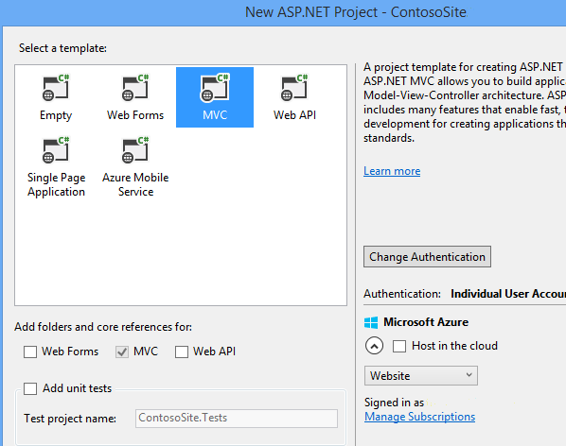

The project is created with the default files and folders.

**REQUIREMENTS**

**SOFTWARE REQUIREMENTS**

Visual Studio 2013

SQL Server Express Edition 2012

Google Chrome or any other web browser

Operating System can be Windows XP and above, LINUX and Mac etc.

**Hardware Requirements**

1.6 GHz or faster processor.

1 GB of RAM (1.5 GB if running on a virtual machine)

10 GB (NTFS) of available hard disk space.

5400 RPM hard drive.

DirectX 9-capable video card running at 1024 x 768 or higher display resolution.

**Supported Operating Systems**

Windows 8.1 (x86 and x64)

Windows 8 (x86 and x64)

Windows 7 (x86 and x64)

Windows Server 2008 R2 SP1 (x64)

Windows Server 2012 (x64)

**Supported Architectures**

32-bit (x86)

64-bit (x64)

**CMC-Schneider Account Management portal in asp.NET**

CMC-Schneider Account Management portal in asp.NET is a web application to be used internally. Later on , the application will also be taken over by other zones in the SEZ and replicated throughout the company after the required customizations are made. The asp.net web application is done in Visul Studio 2013, Microsoft’s flagship integrated development environment and also uses various concepts like Code First Architecture, Scaffolding, MVC Architecture , Entity Framework and LocalDB , to name a few. The entire web application is responsive, as the bootstrap framework is being used , along with Javascript, apart from the standard HTML5 and CSS. Visual C# has been used to code the entire project.   
It acts as an information portal for various users. It is done in Microsoft Visual Studio 2013 IDE. There are a number of activity screens. To specify in brief, the homepage , the about page , the contracts page , the projects page, the employees page and the jobs page. There is CRUD functionality for Contract, Project,Employee and Job options. There is also an Image Gallery option where the employees can upload pictures of different team events. A login and register option is also present for the administrator to register ( after which the register functionality can be removed, if required. Additionally, the controller can also be modified to ensure that everyone has to register to view the site , while only the administrator has the option of accessing the edit, delete and create new functionality). Apart from this , there is also an About Us page which gives the Project Statistics.

**Screenshots and explanation:**

The Home page , which is visible as soon as the project is running. The navigation bar has six main options, as can be seen from the screenshot. The left side has a Quick Links section , which can be used to provide links to Coding standards , Downloads, Best practices etc. The right side of the page is a PDF file ( for sample purposes, a random PDF file is being used). Code has been written so that the number of pages in the PDF file are read, and each page is displayed one at a time in the browser. Additionally, user also has the option of going to the previous \ next page by clicking on the left\right glyphicons. The current page is displayed in a ordered list format ( with a black circle and white background). 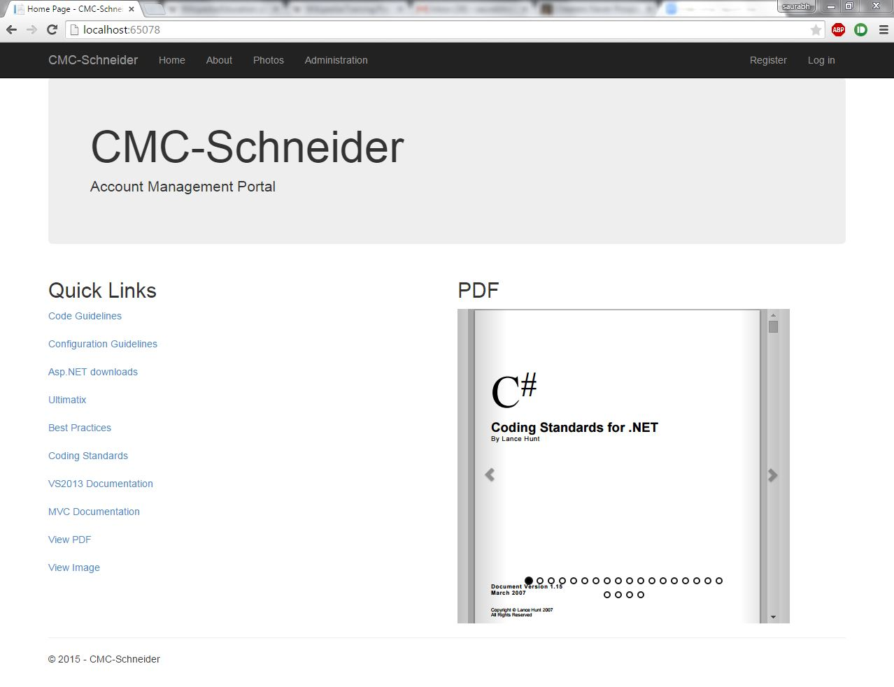

2.

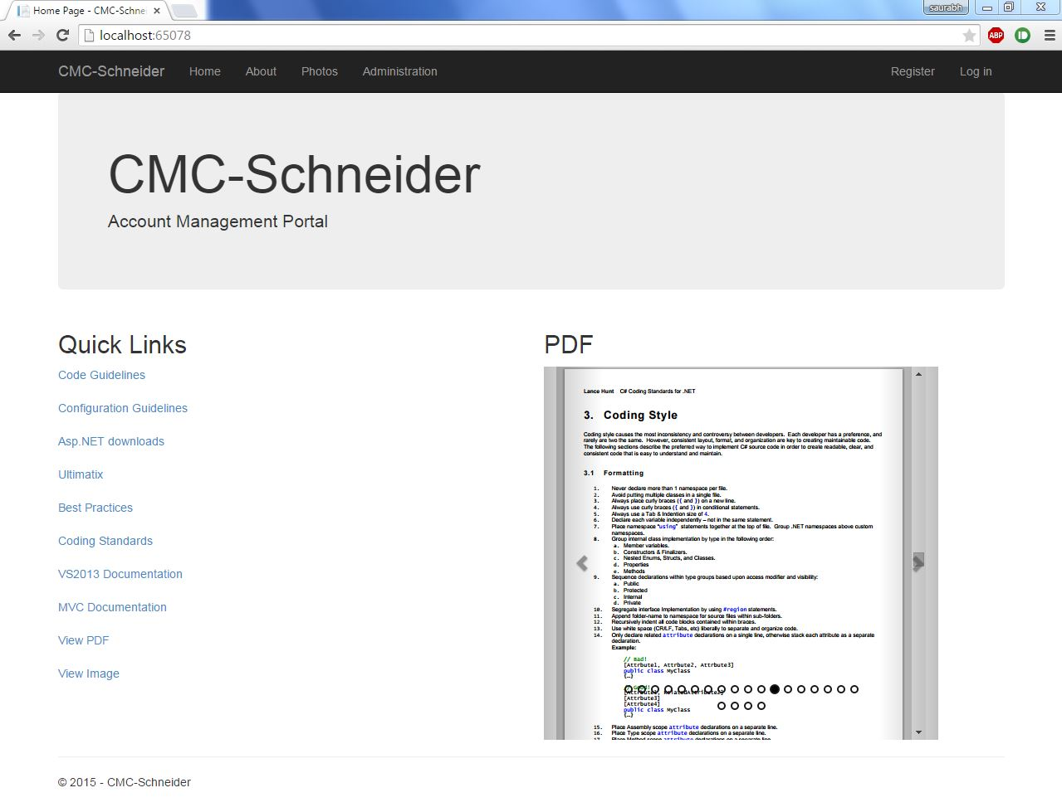

The pages are loaded as a bootstrap carousel , and they start moving with a fade animation from right to left.

3.

The About Us page describes project Statistics, which have been grouped by their Start Date. This Page is updated dynamically as soon as Projects are added.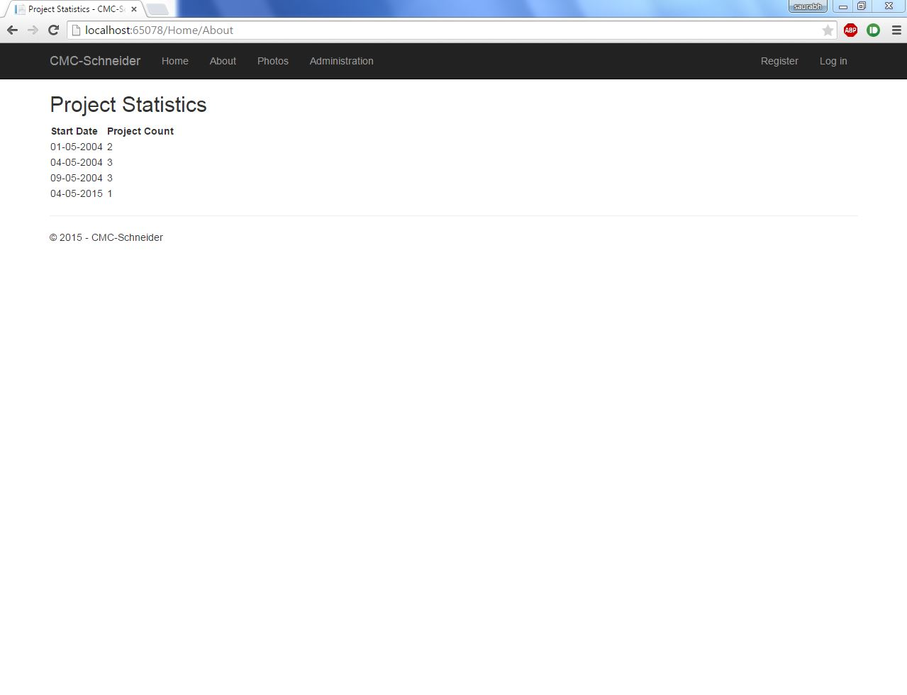

4.   
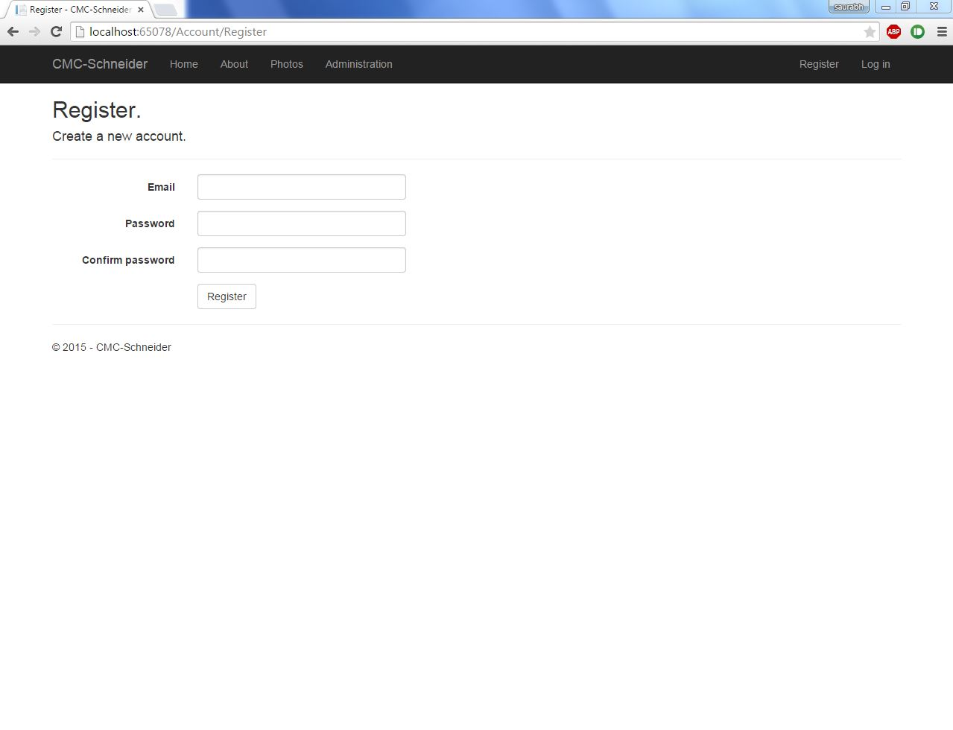

To access edit, delete and create new options of Project,Contract,Employee and Job, the administrator first has to register. Registration is done by email ID and password.

5.

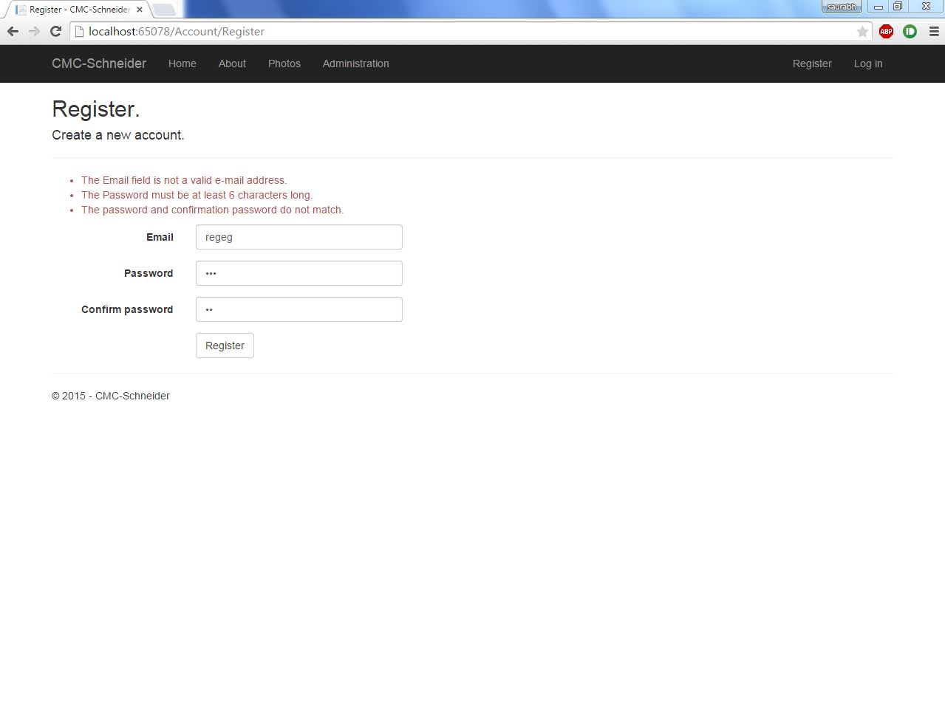

Constraints have been applied to ensure user inputs all details correctly.

6.

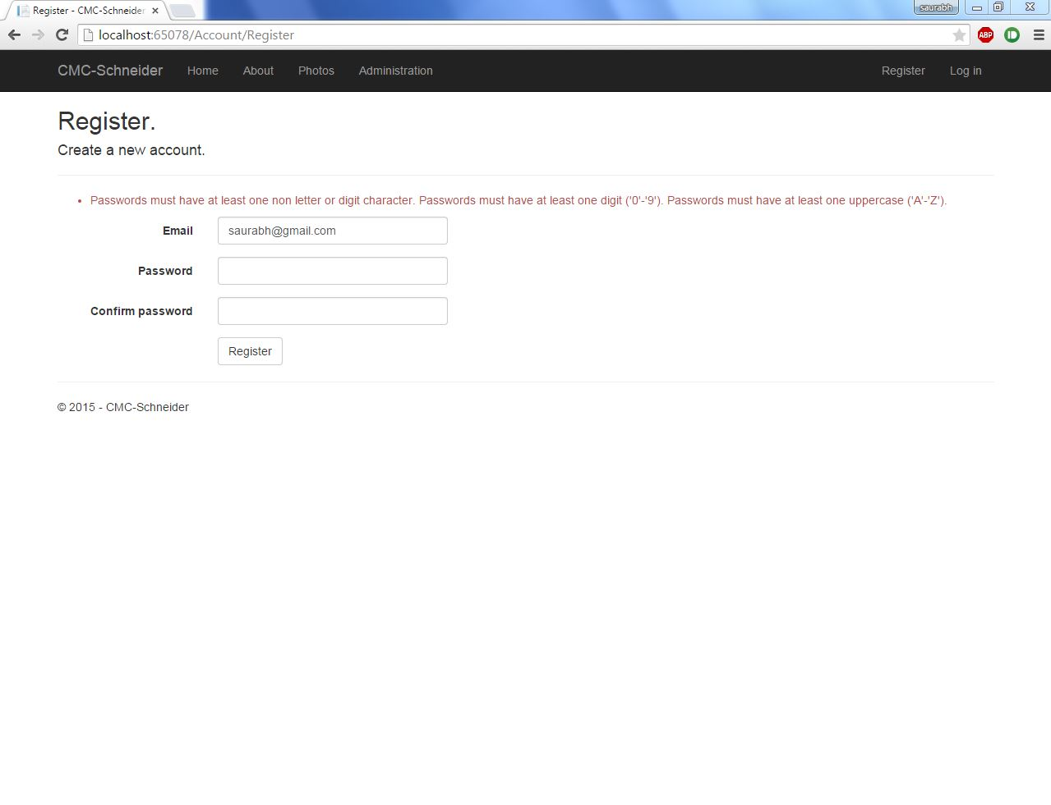

Constraints have been applied to ensure user inputs all details correctly.

7.

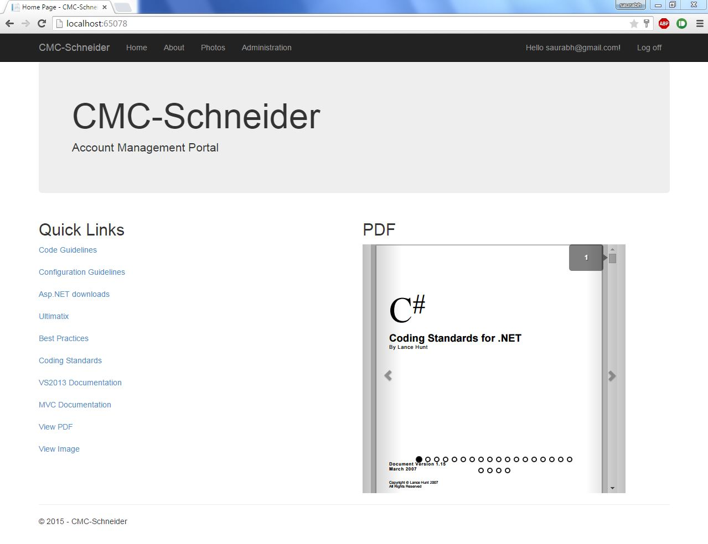

Page seen after logging in.

8.   
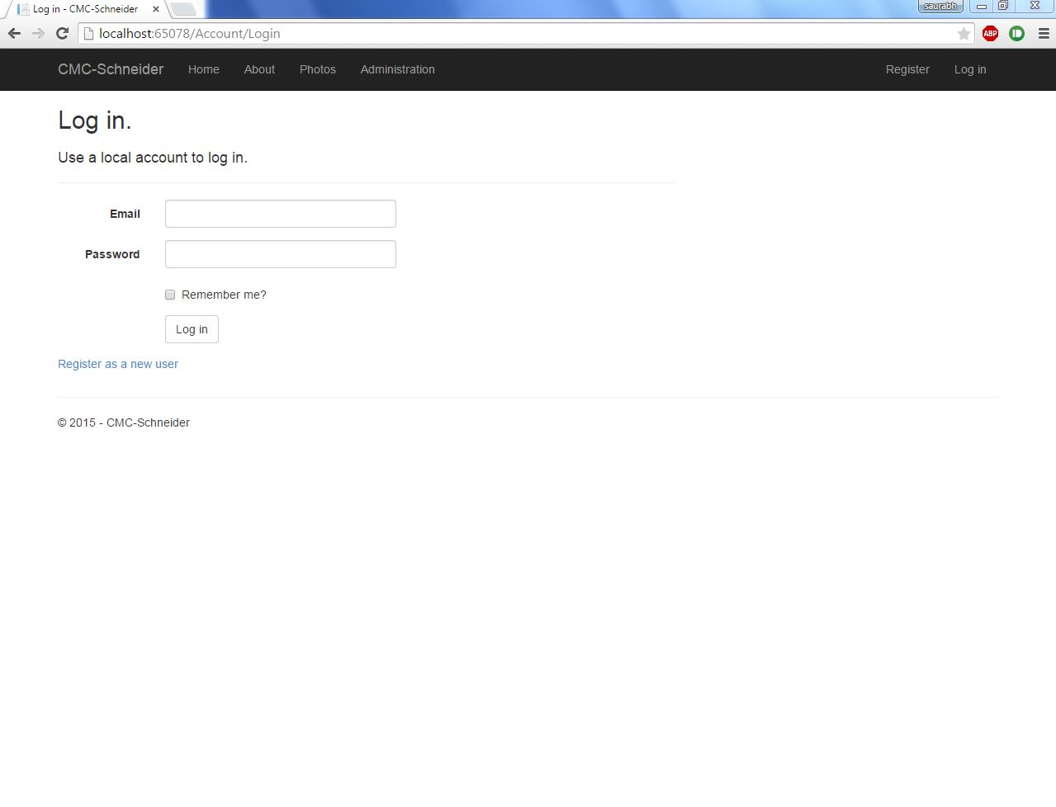

Alternatively, a user already in the database can simply login by providing the necessary credentials.

9.   
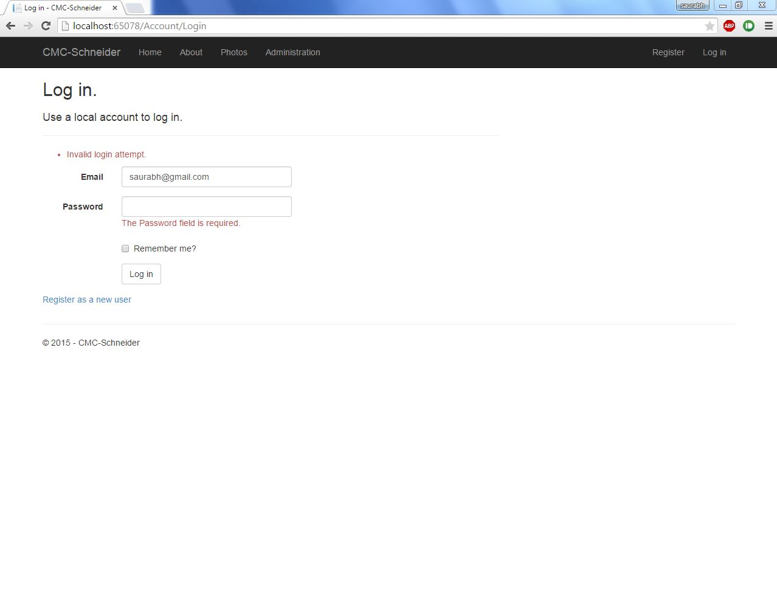

Constraints have been applied to ensure user inputs all details correctly.

10.

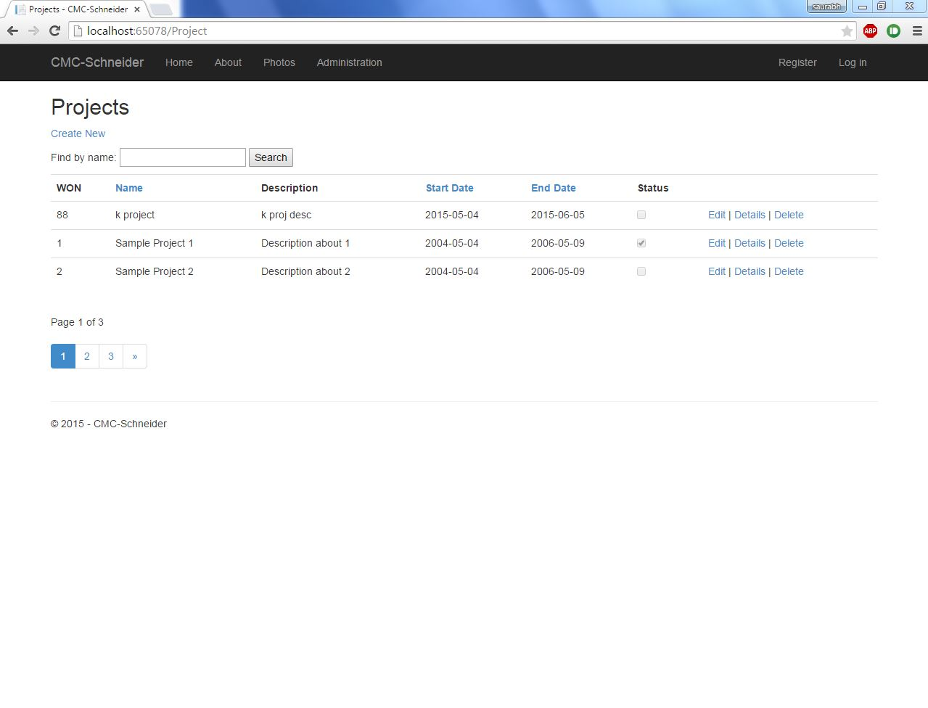

Projects Index page. Each Project has a unique WON (Work Order Number). The Projects can be ordered by Name, Start Date or End Date in an ascending or descending fashion. User also has the option of searching for the projects. Possible to access Create new, edit and delete functionality only after logging in. Paging option has also been enabled (Restricted to three results per page).

11.

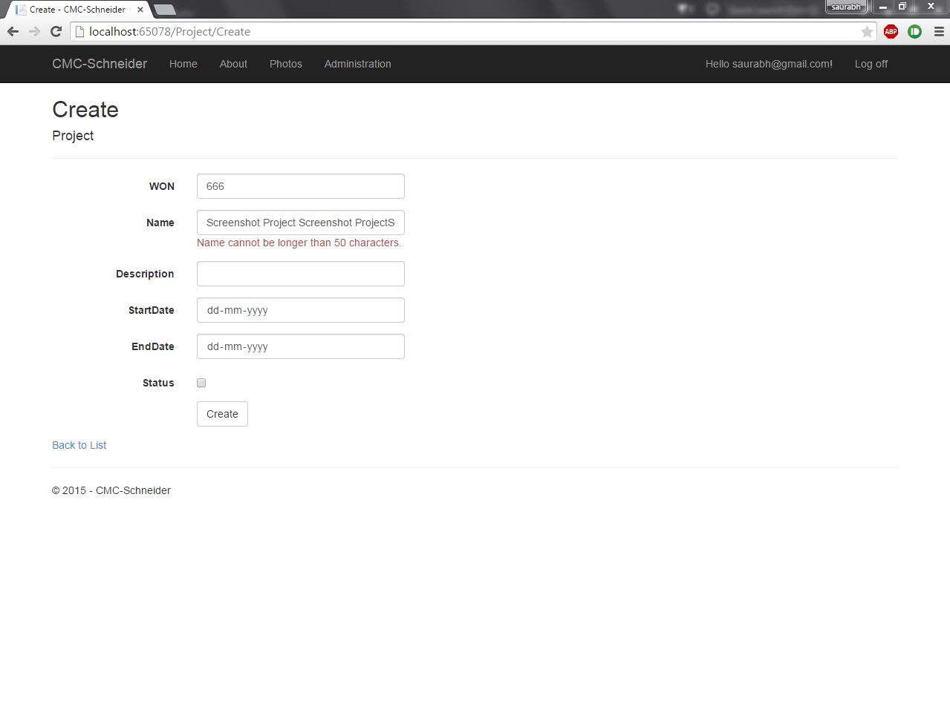

Create New page for Projects. Constraints have been applied as per requirements.

12. 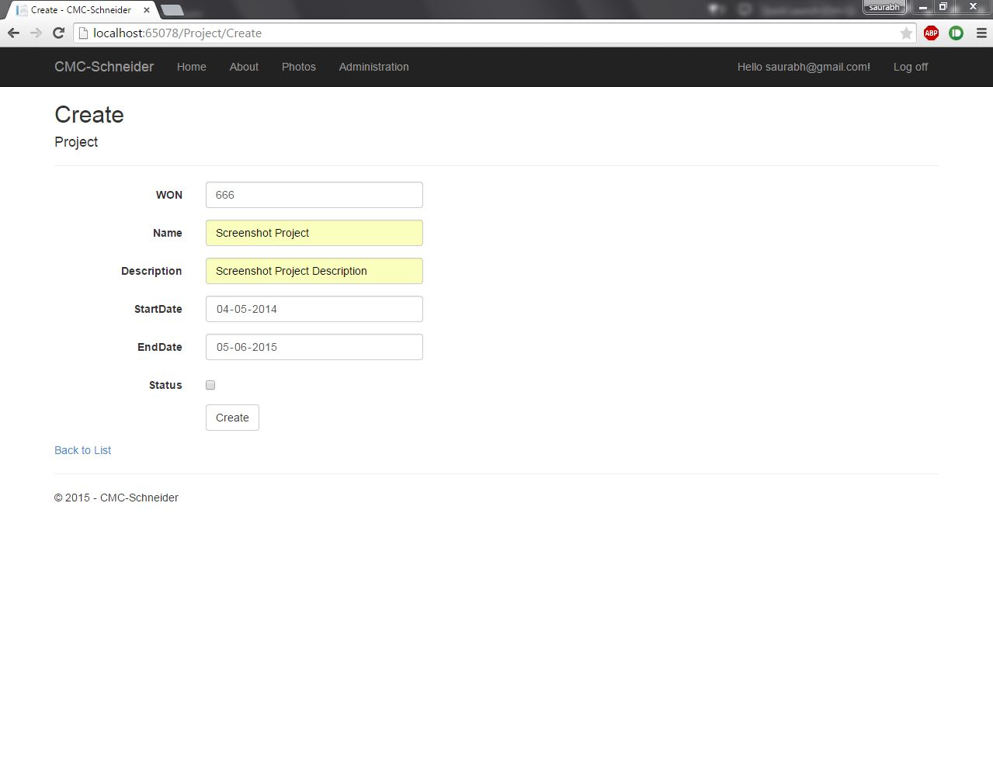

Project Create New option.

13.

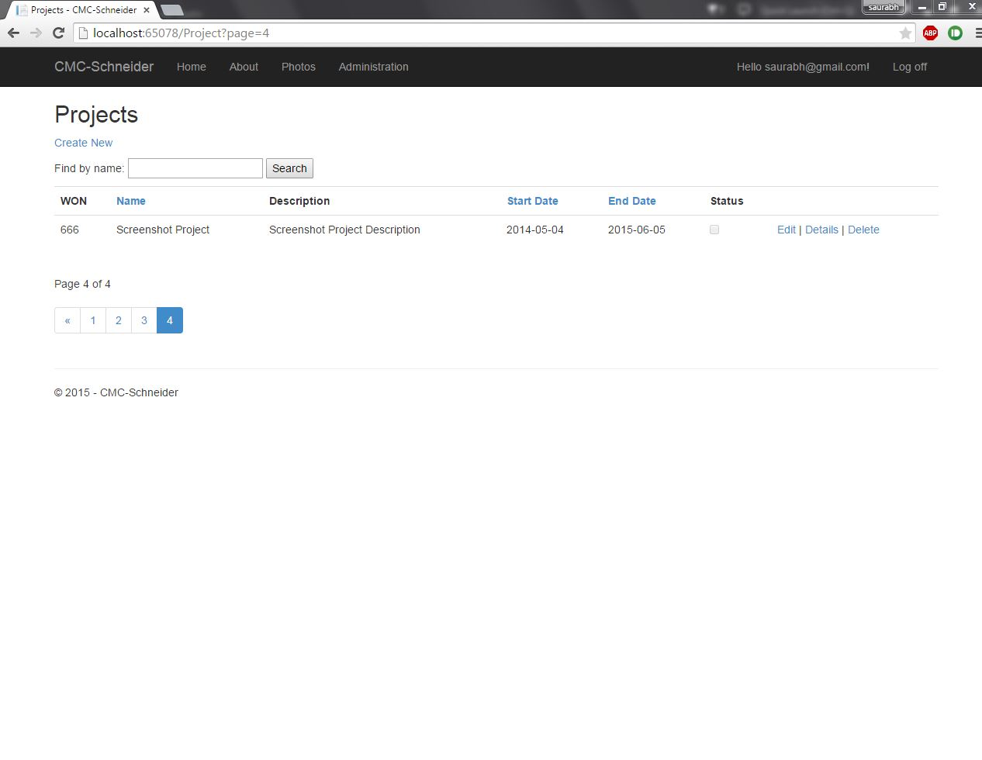

Index Page after new project has been created.

14.

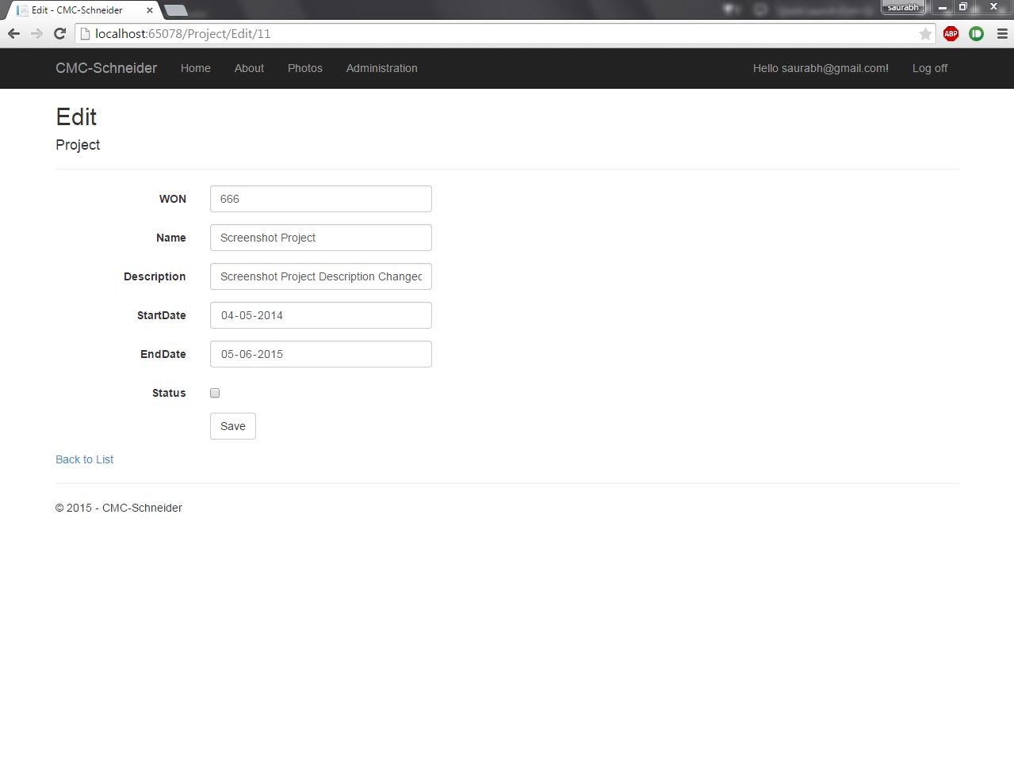

Edit option for project. Available only after logging in.

15.

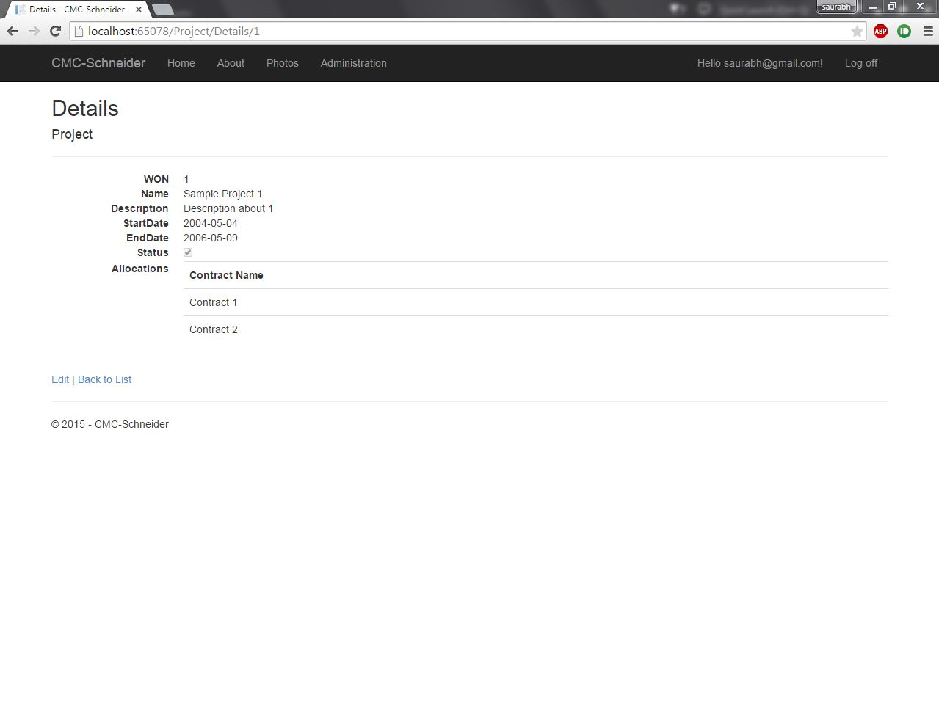

Details option for projects. Available without logging in also.   
16.

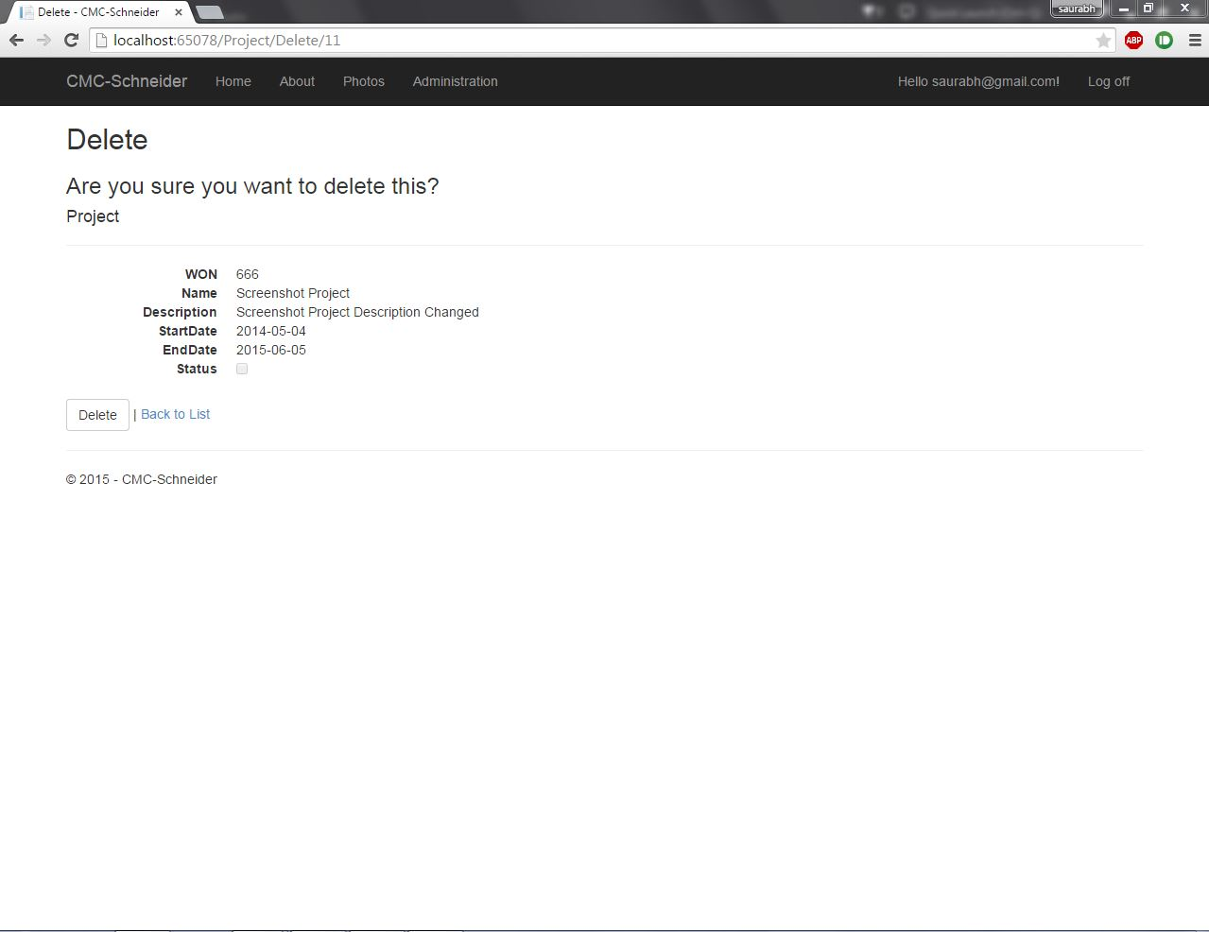

Delete option for project. Available only after logging in.

17.

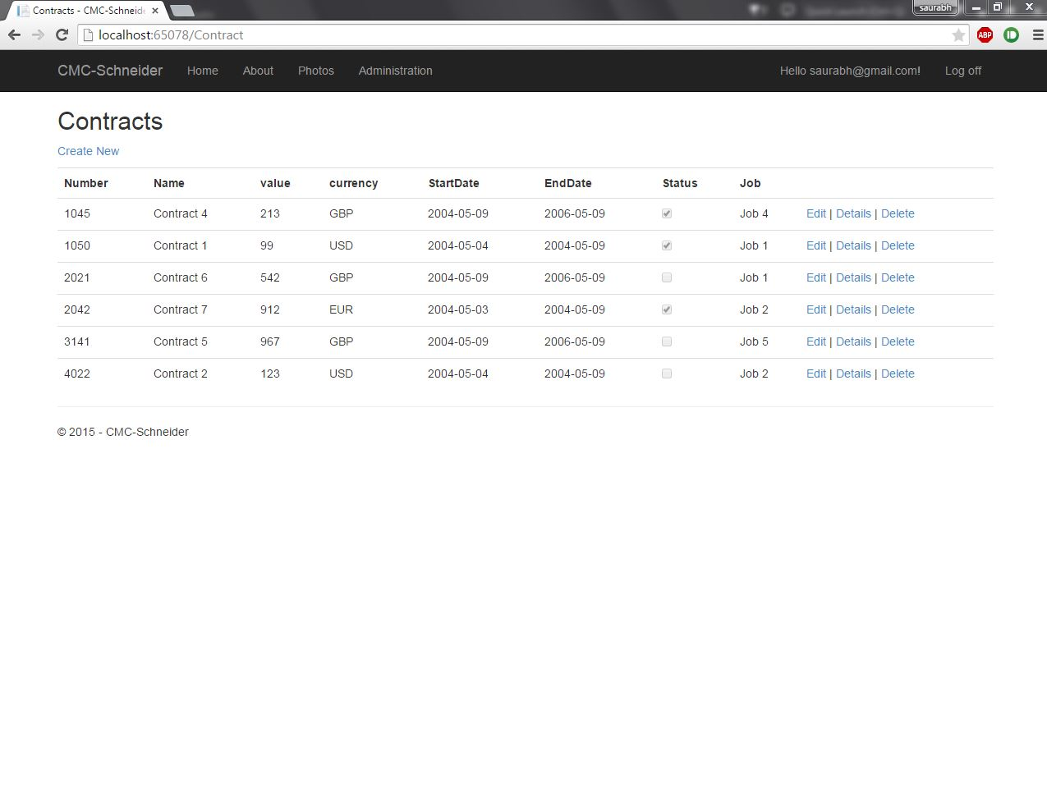

Index Page for contracts. Edit, Delete and Create new functionality available only after logging in. Each Contract has a specific Job Number , which has to be taken care of by a particular employee who has been assigned to a particular contract.

18.

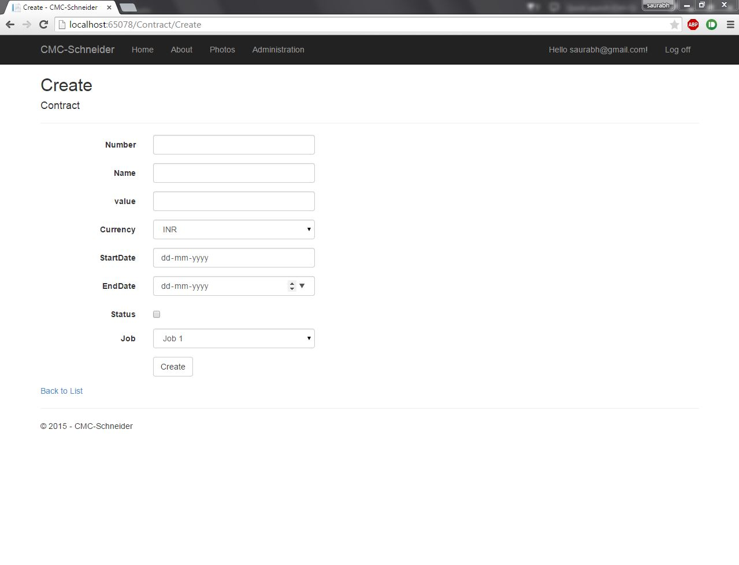

Create New option for Contracts.

19.

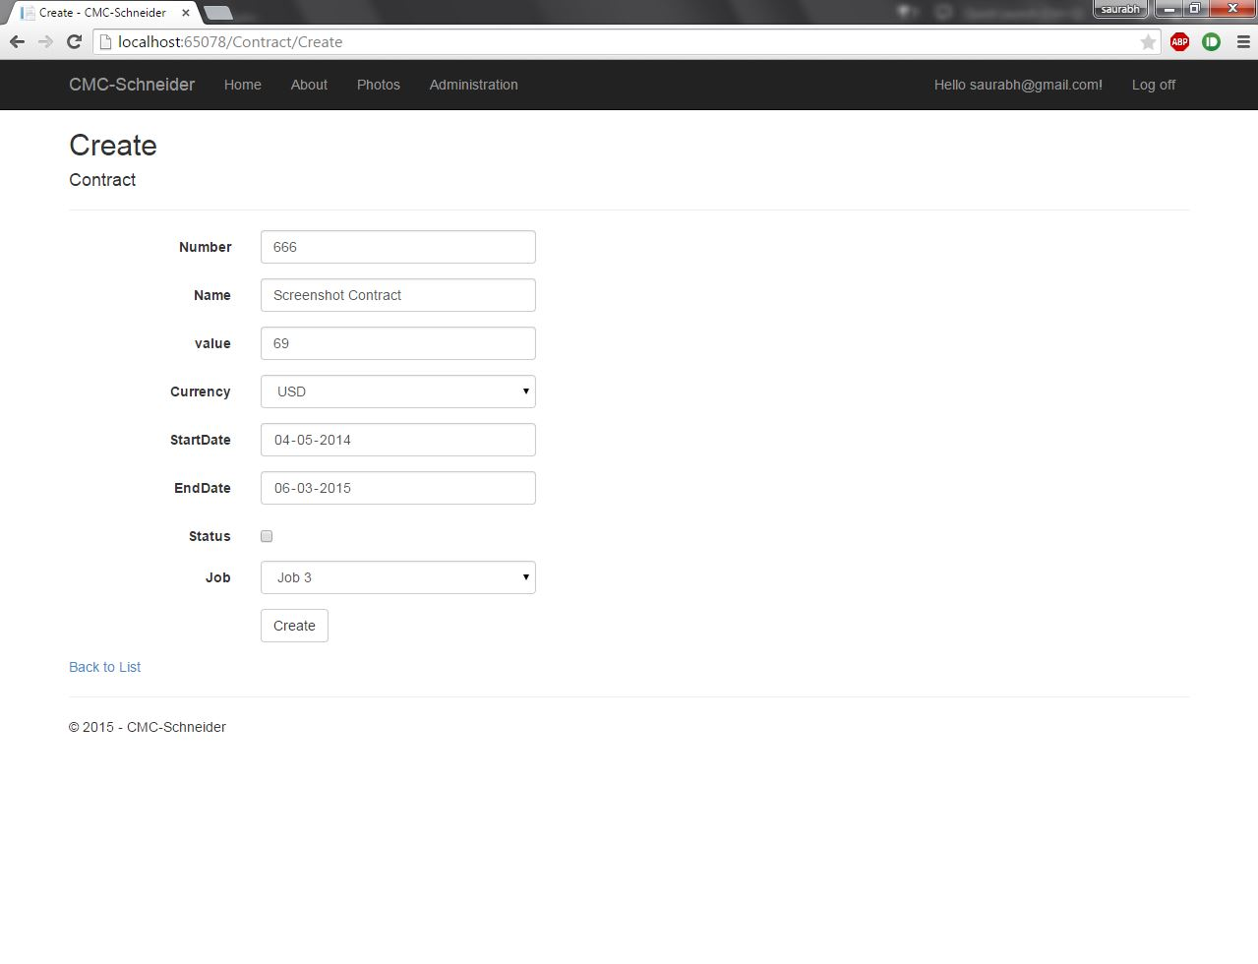

After filling out details for new contract. Restrictions based on requirements have been applied.

20.

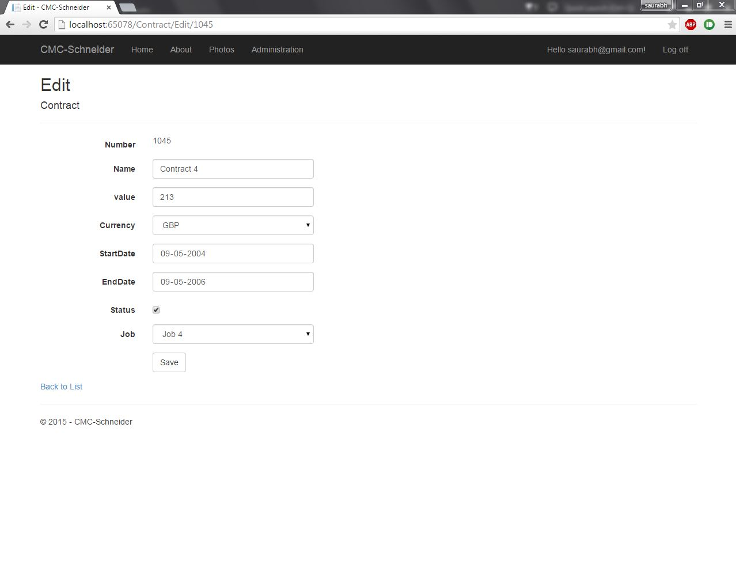

Edit option for Contracts.

21. 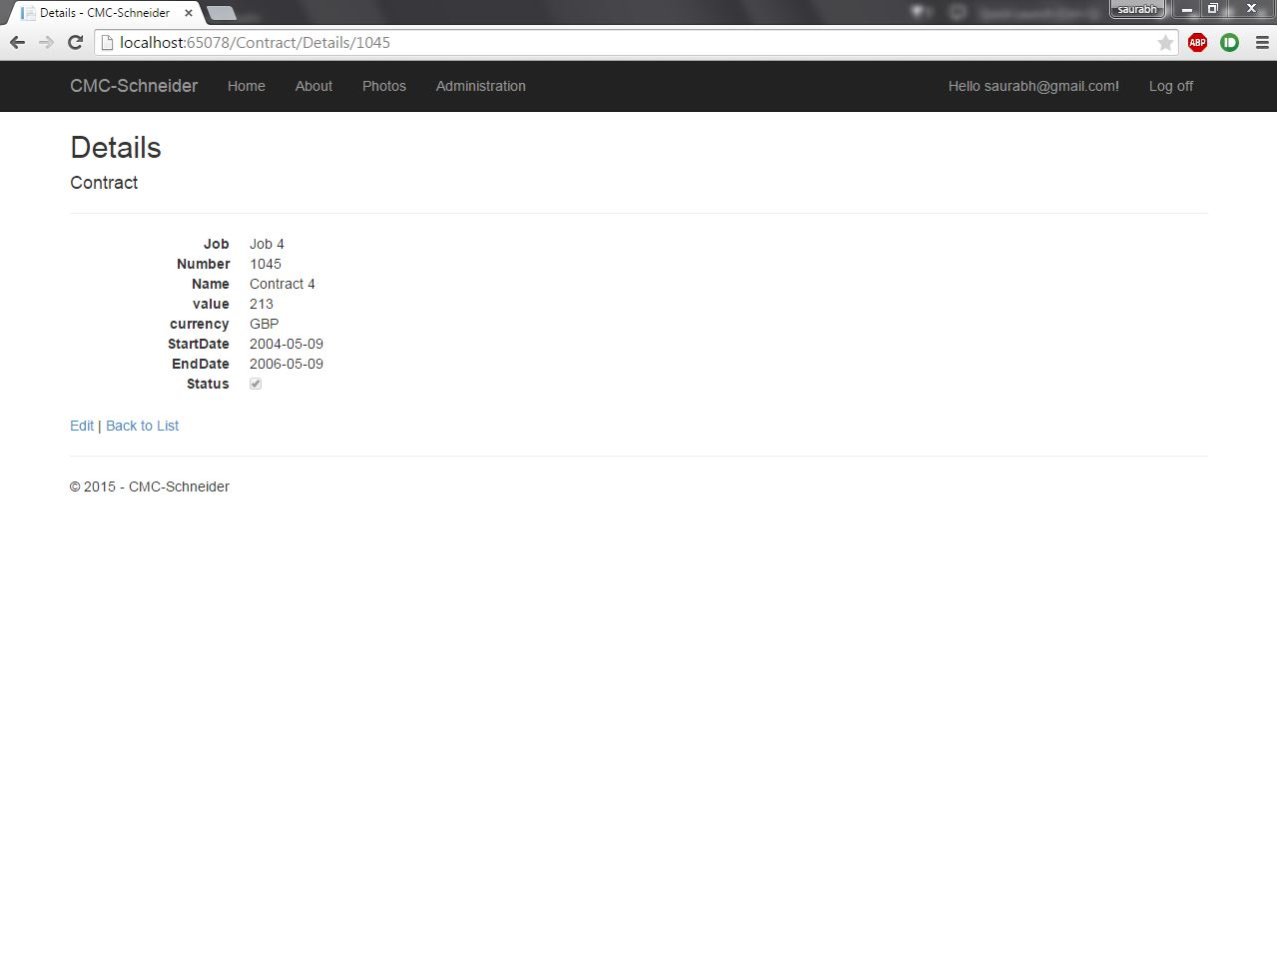

Details option for Contracts. This option is available even without logging in.   
22.

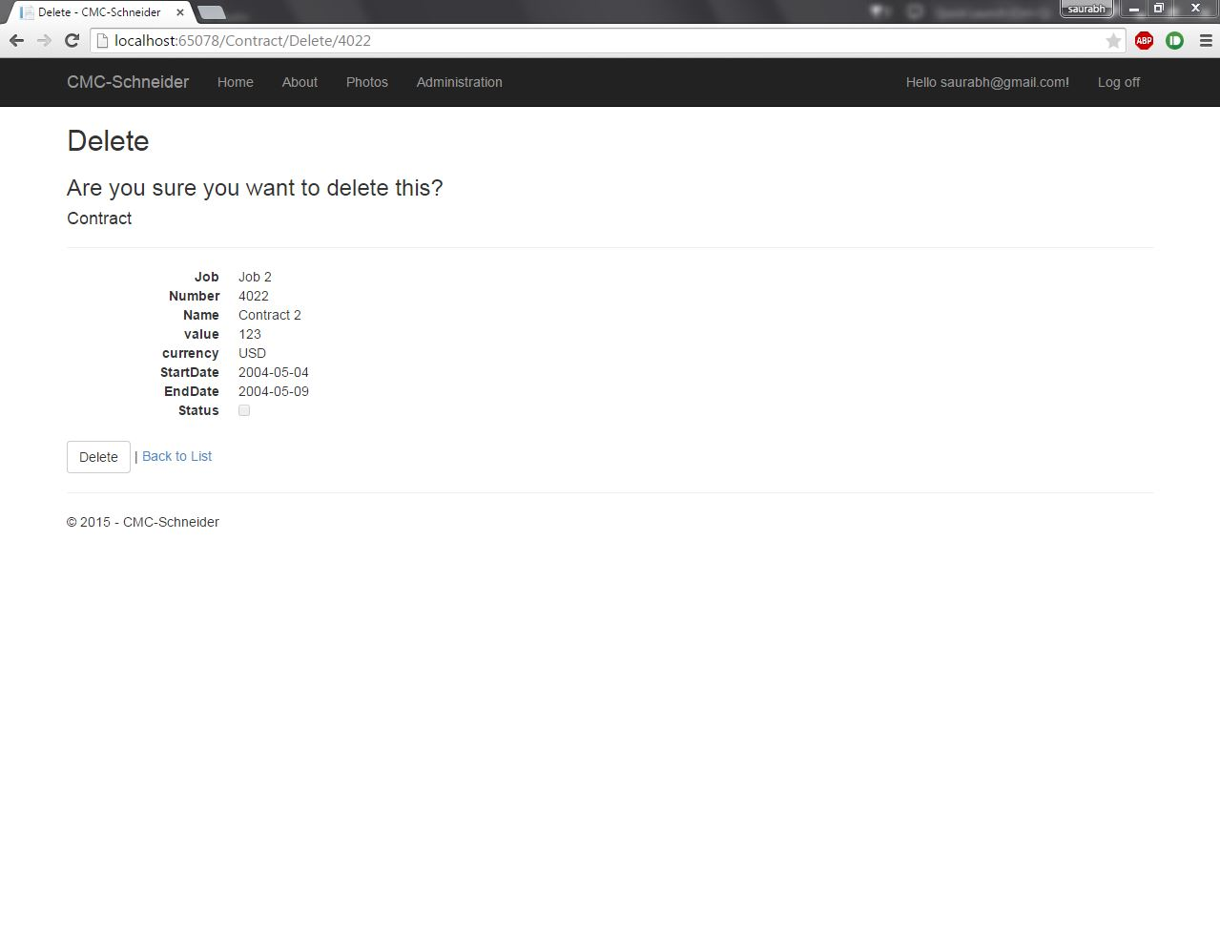

Delete option for Contract.

23.

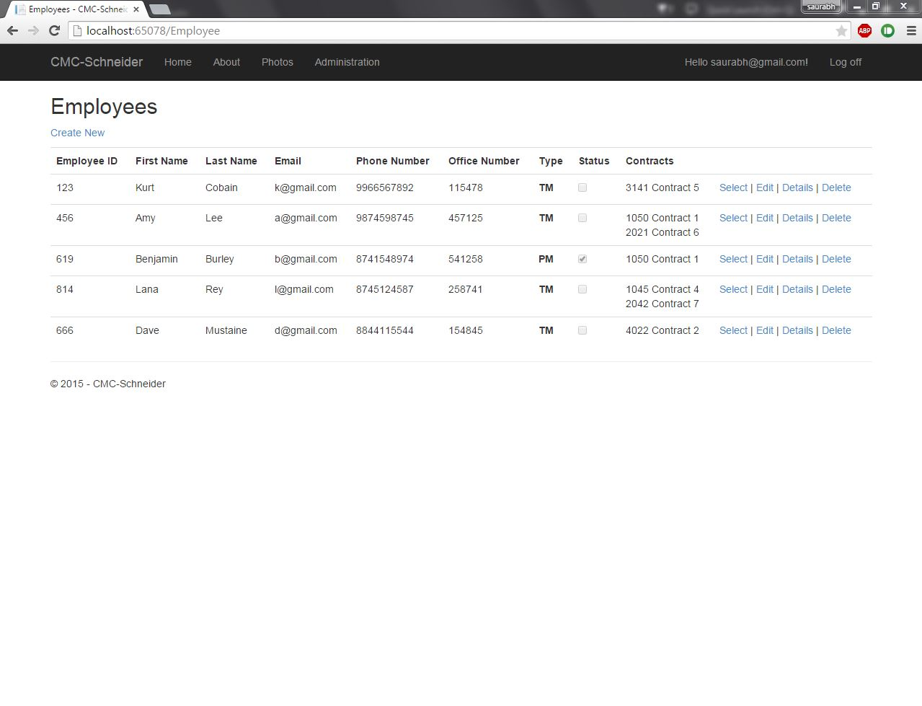

Main Index page for Employees. Each employee has a unique Employee ID. Each Employee is assigned one or more Contracts.

24.

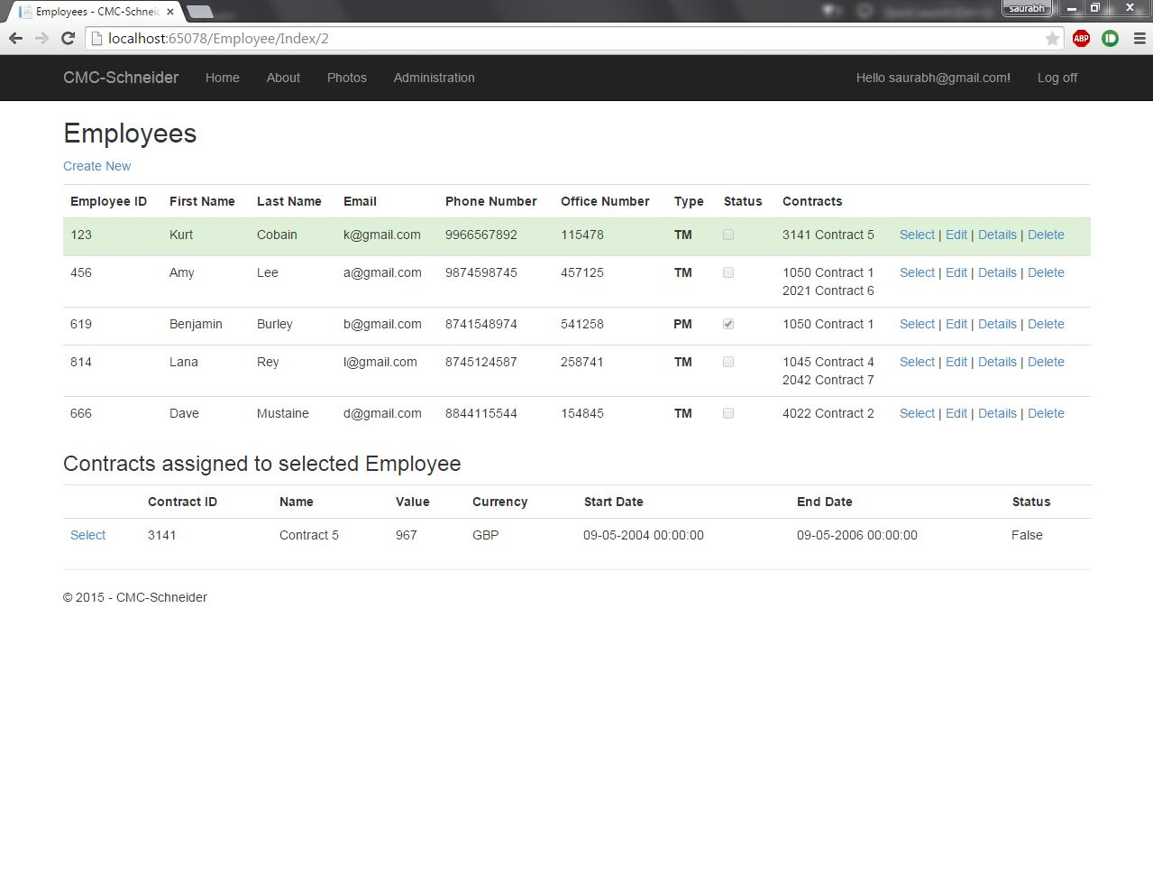

On selecting a particular employee, the contracts assigned to that employee are shown.   
25.

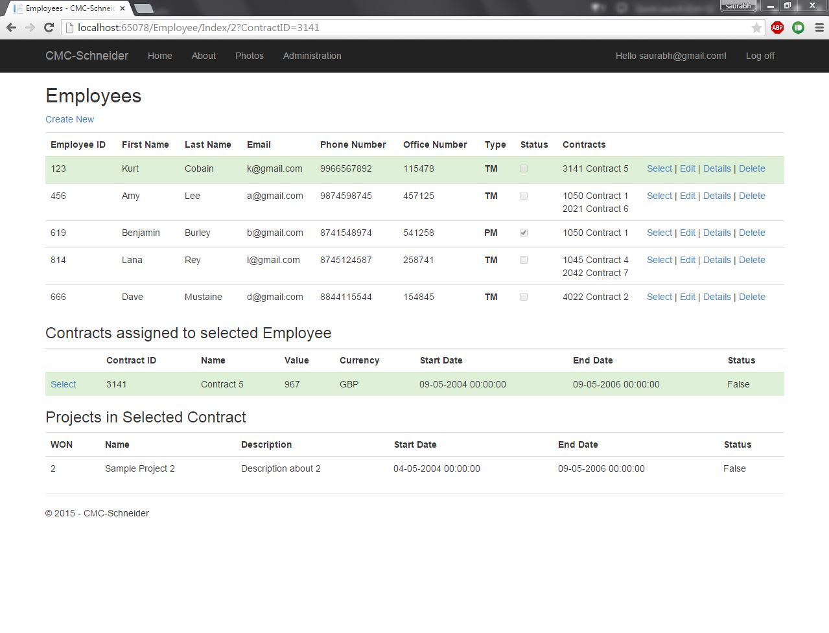  
On selecting a contract, the projects in that particular contract are shown.   
26.

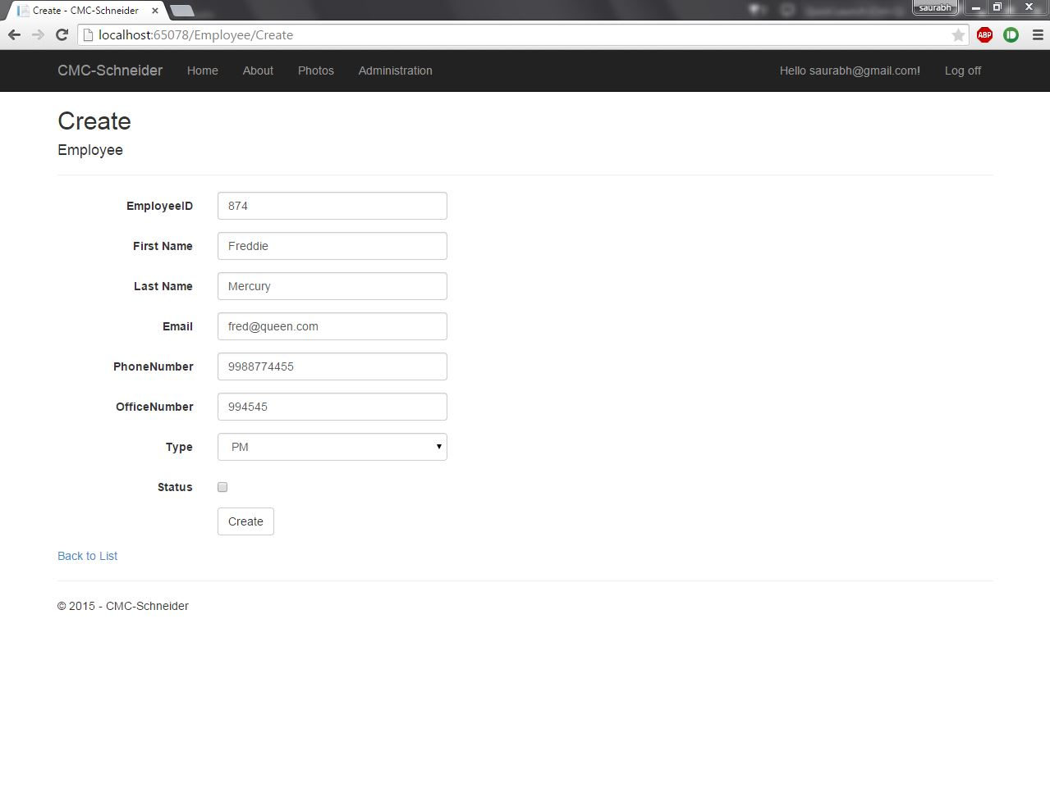  
Create New option for employee. Constraints have been applied according to requirements.   
27.

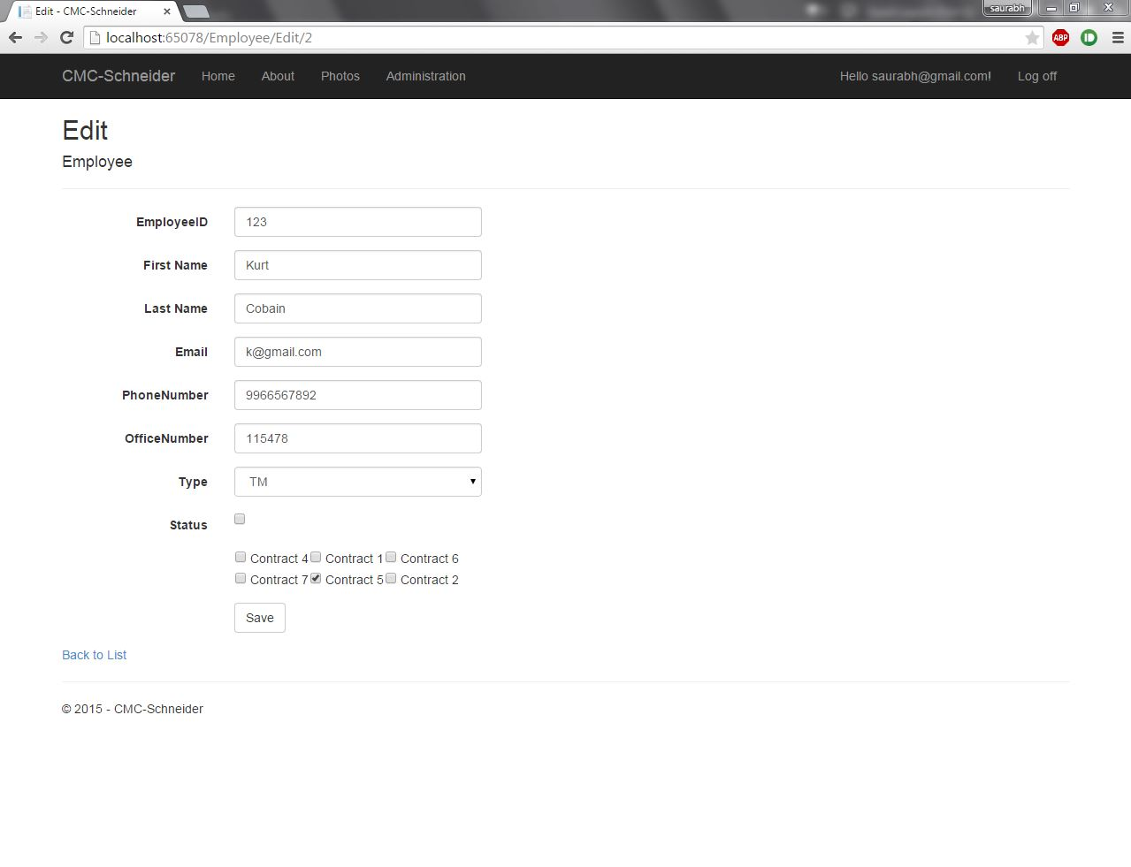

Edit option for Employee.   
28.

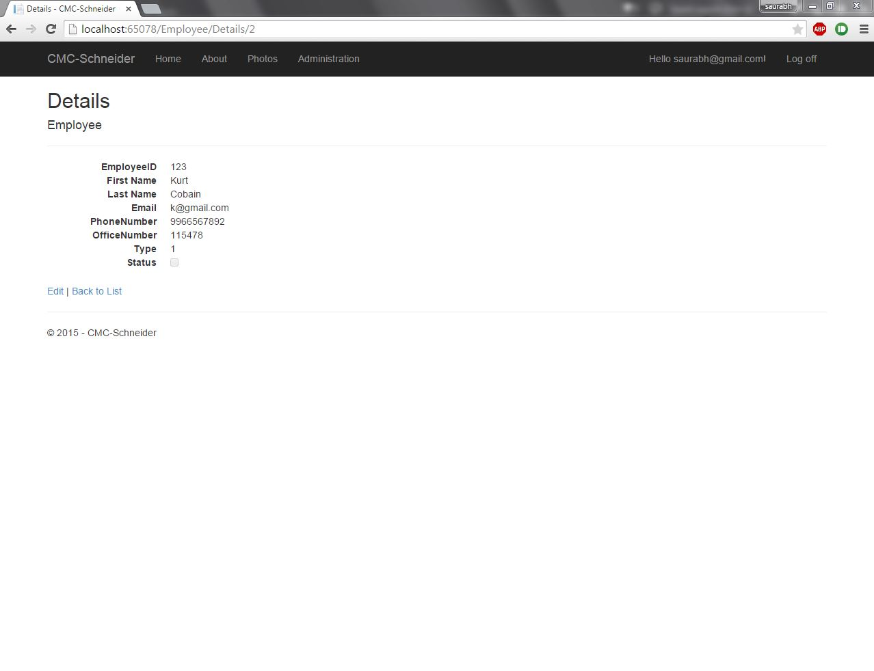  
Details option for employee.

29.

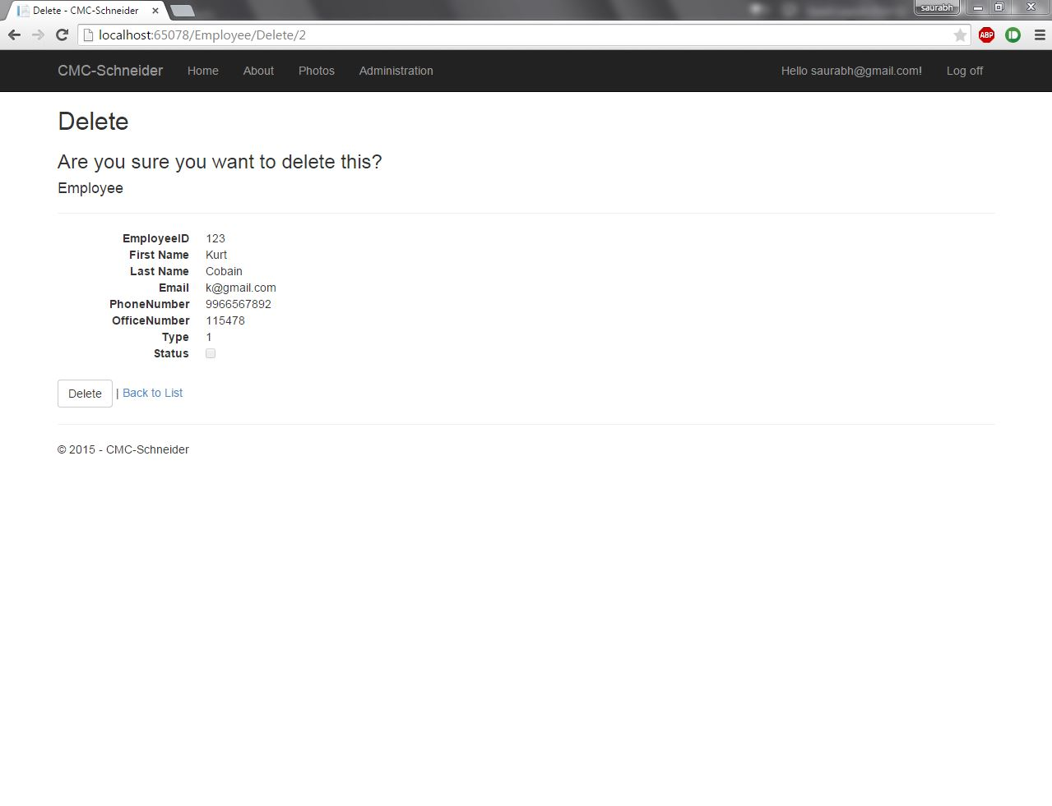

Delete option for employee.   
31.

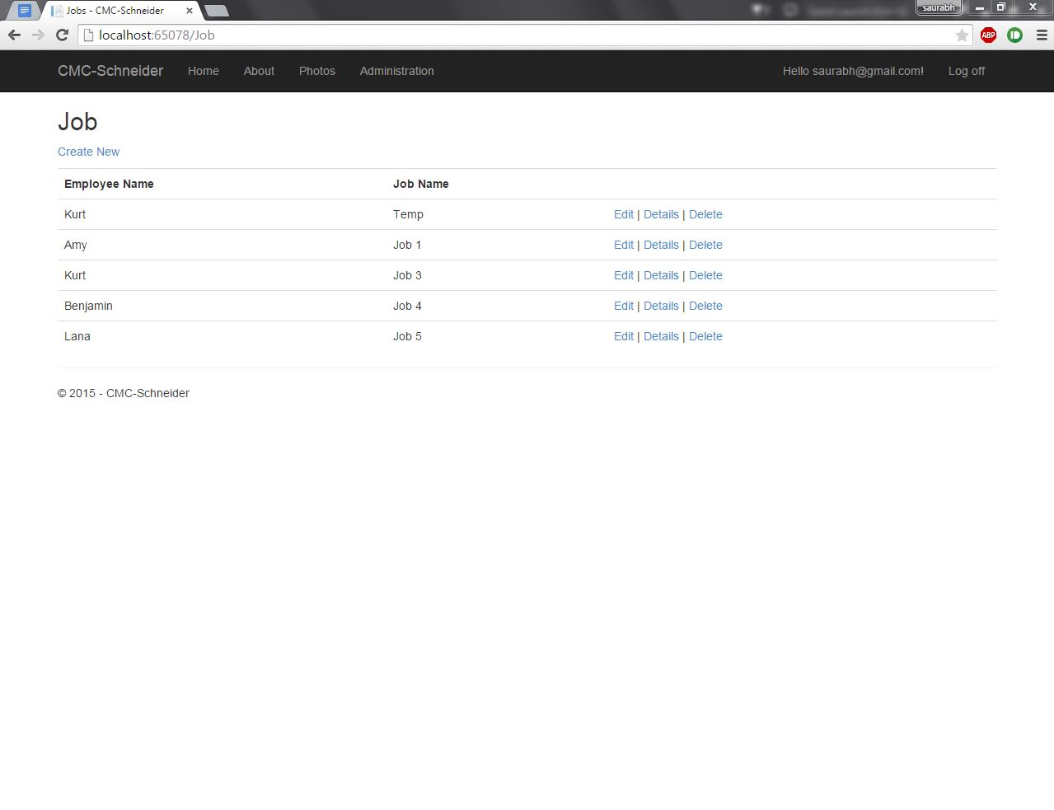

Index Page for Job. Async Controllers are being used along with Stored procedures.   
32.

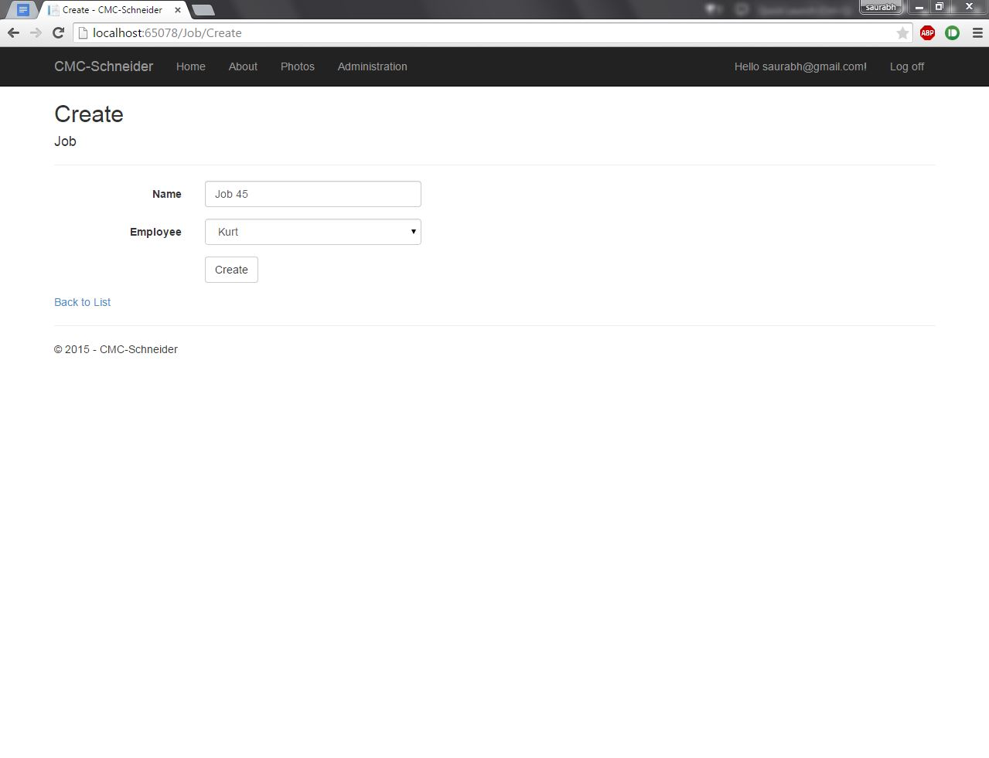

Option to create a new Job. Available only after logging in.   
33.

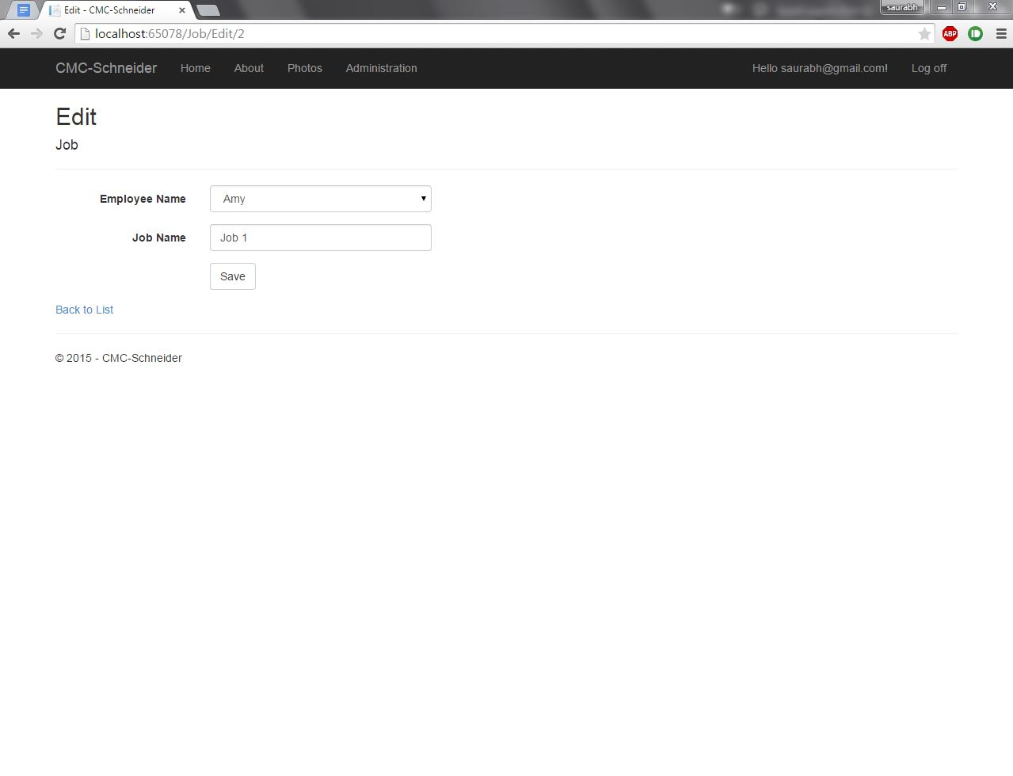

Option to edit a Job.   
34.

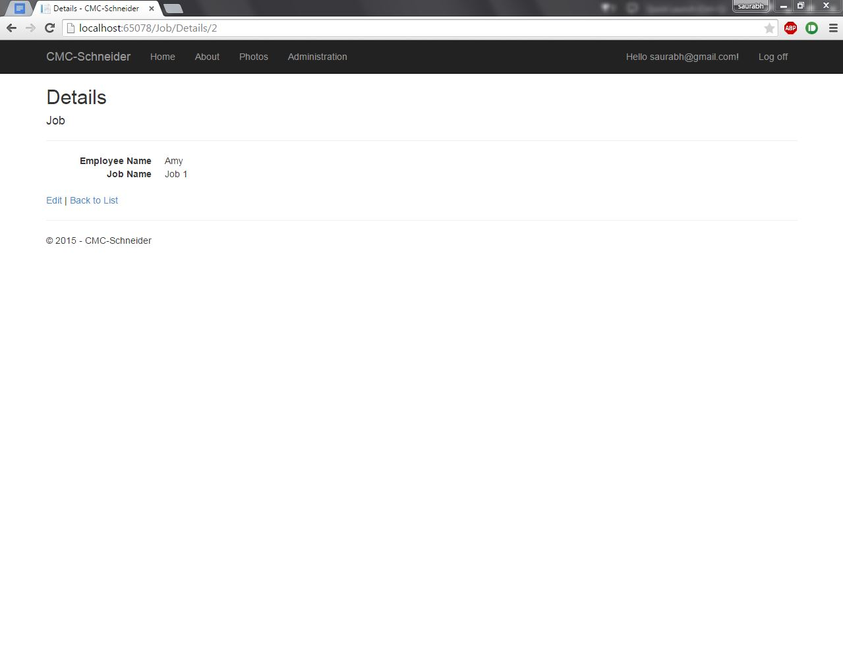

Details of a Job.   
35.

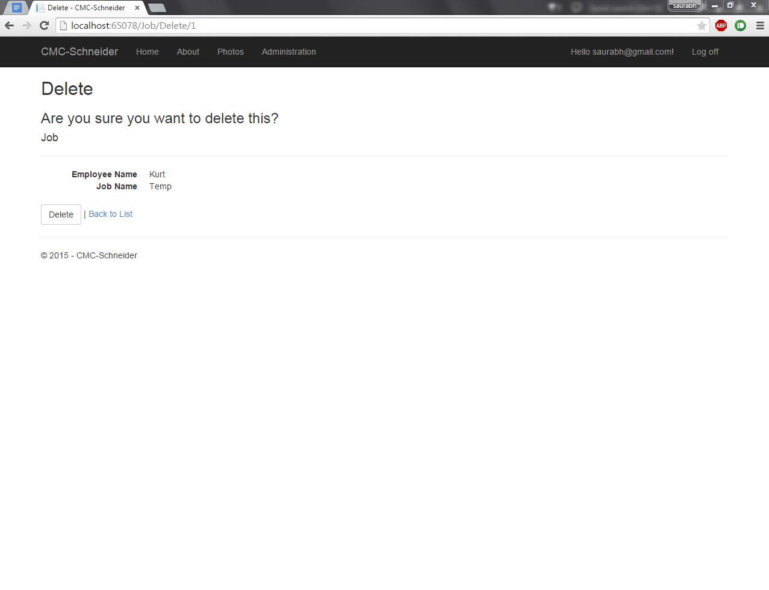

Option to delete a job.

36.

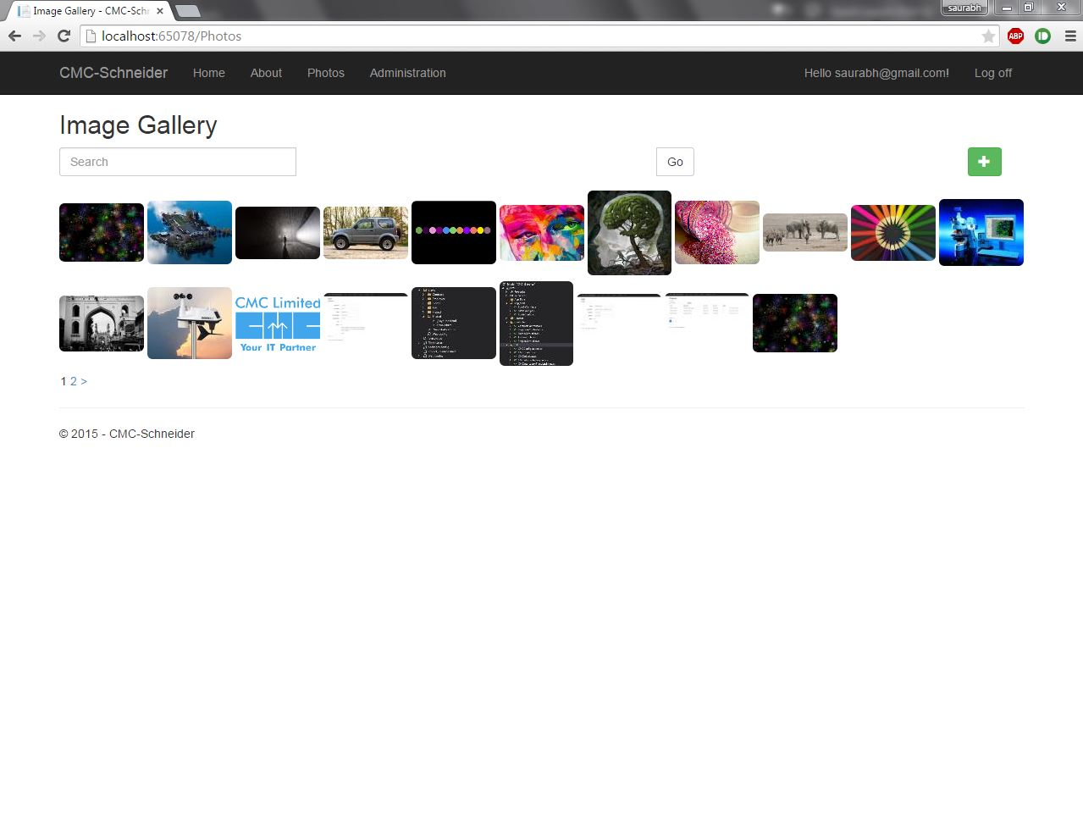

Image Gallery option is also present. It can be accessed without Logging in too. It will be used to upload pictures of team meetings, team outings etc. Upload feature is available even without logging in. Image size settings have been changed to allow any number of files to be uploaded (Default limit is 4MB). User can upload multiple pictures at the same time, with a description for the group of pictures being uploaded. Paging option has also been implemented (Restricted to 20 images per page).   
37.

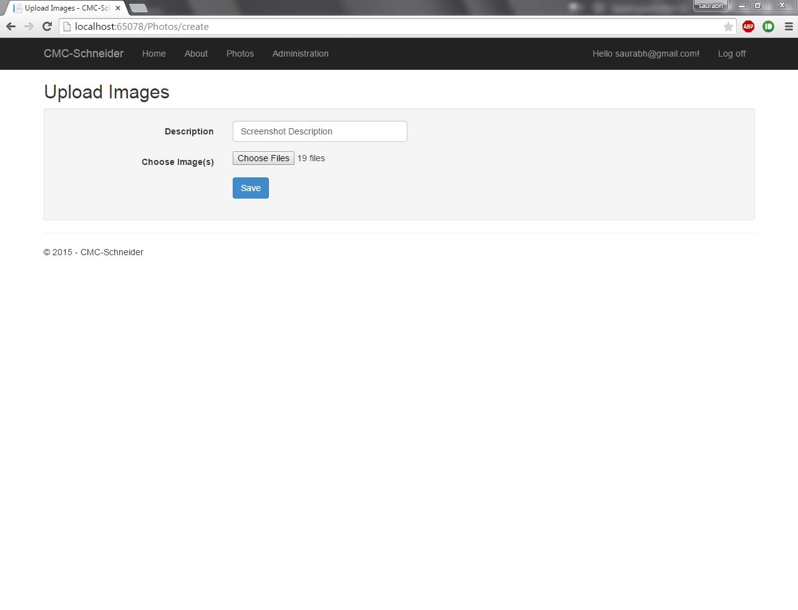

Here, user is uploading 19 pictures with the description “Screenshot description”.   
38.

  
On clicking a thumbnail , a large size preview will open up. User can go to previous\next image by clicking on the left\right glyphicons. A ordered list view is also present at the bottom. The description is mentioned at the top left corner.   
39.

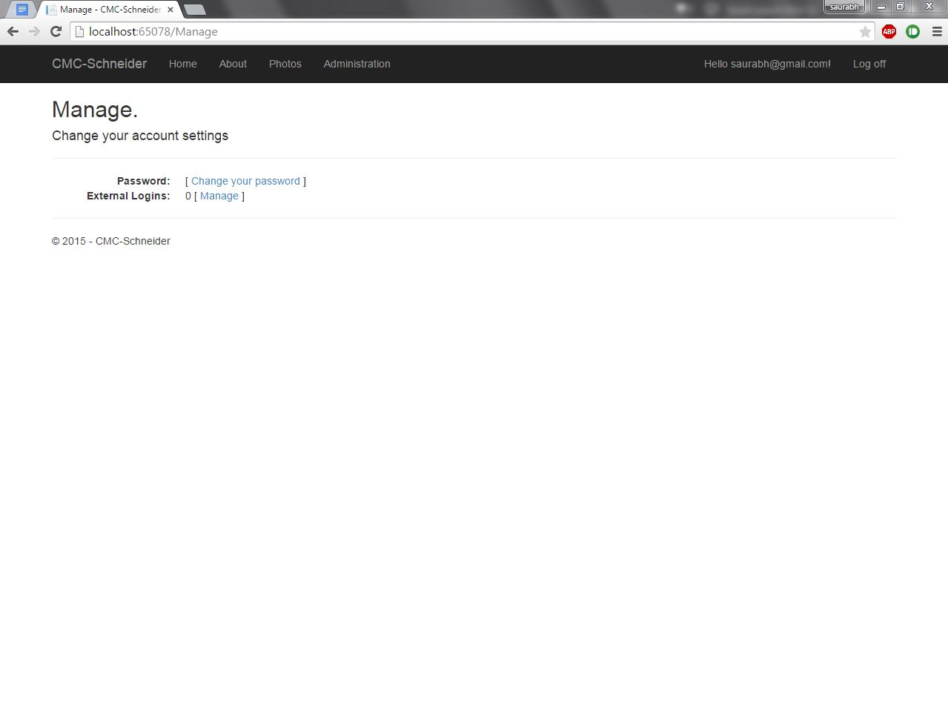

When user is logged in, password can also be changed. External logins can also be managed. For now , external login option is disabled.

40.

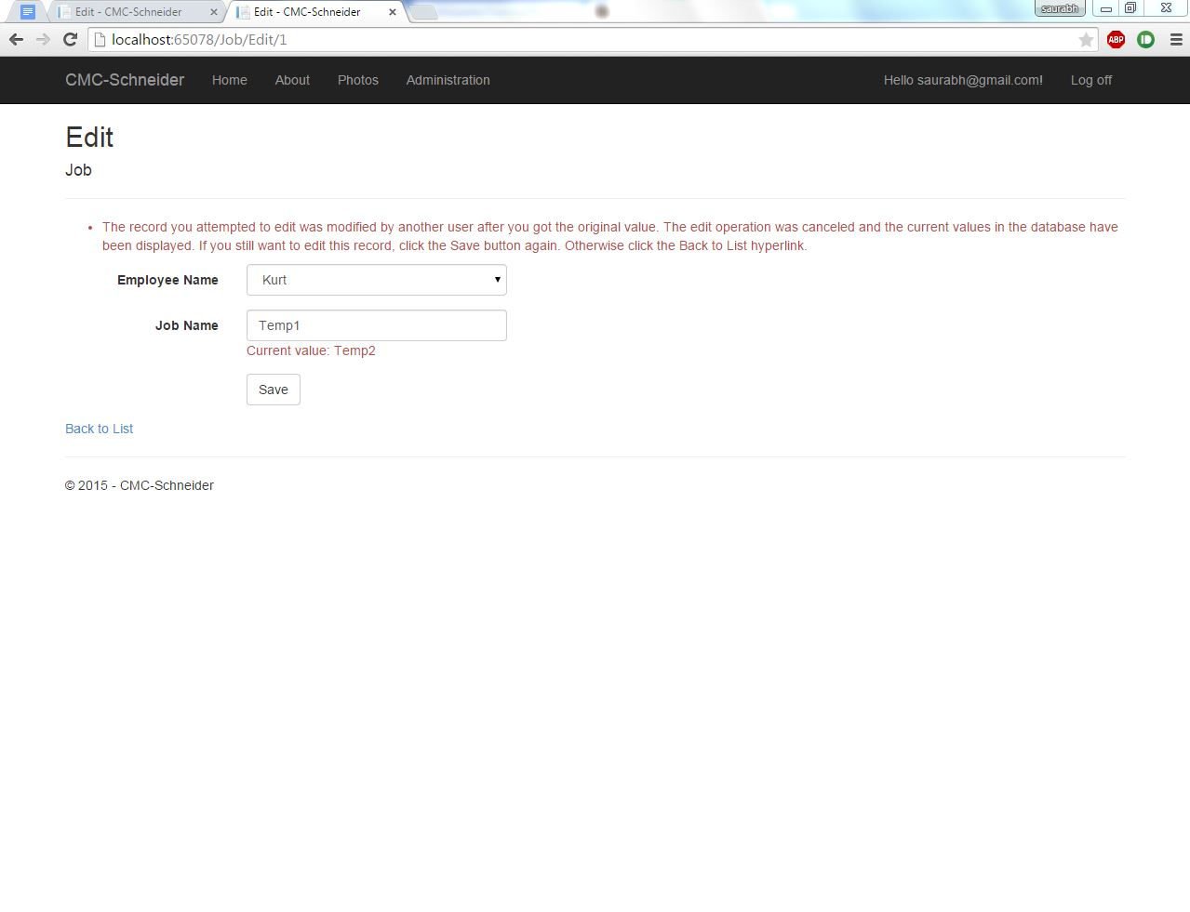

Concurrency has also been handled.

41.

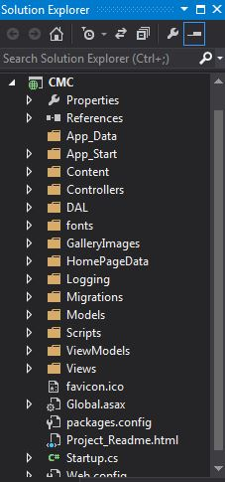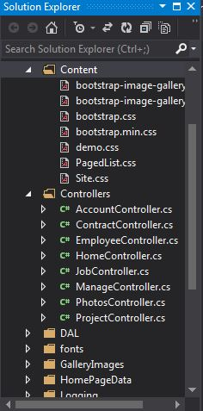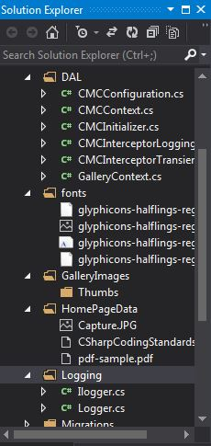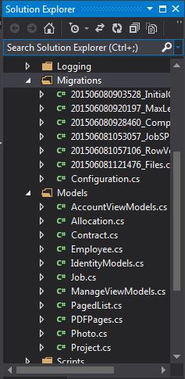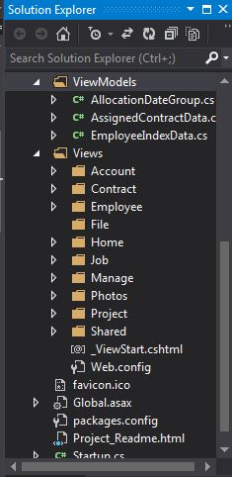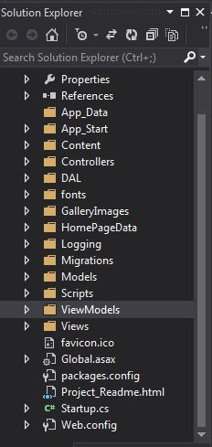

Structure of Solution.

42.

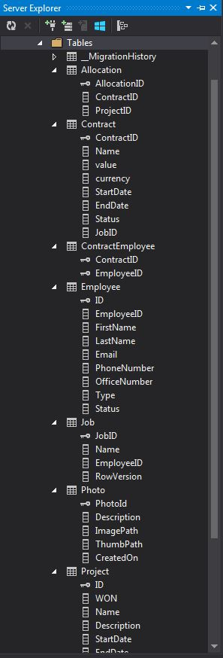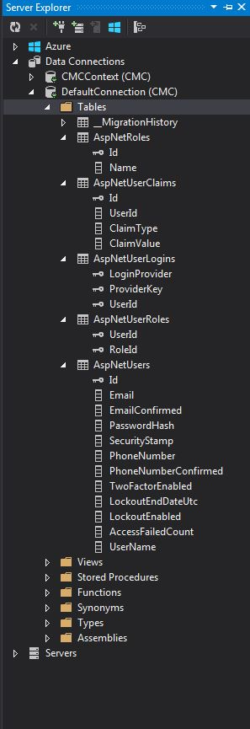

Structure of Database

43.

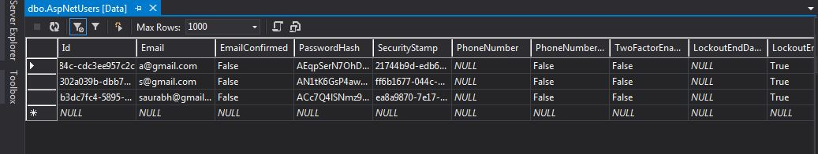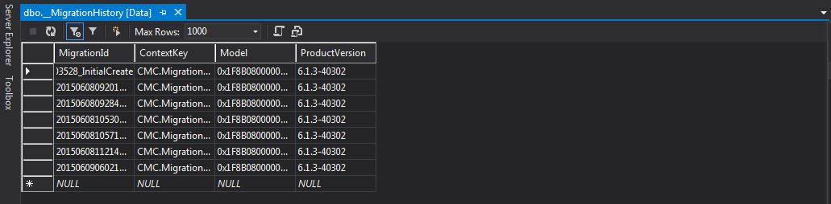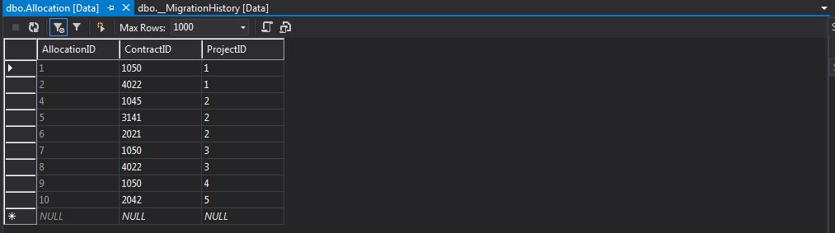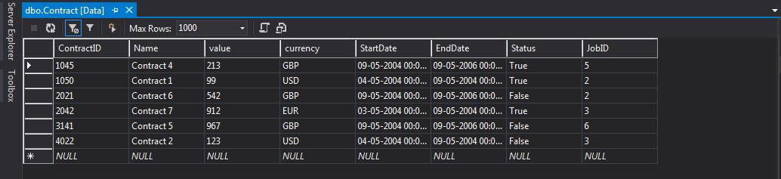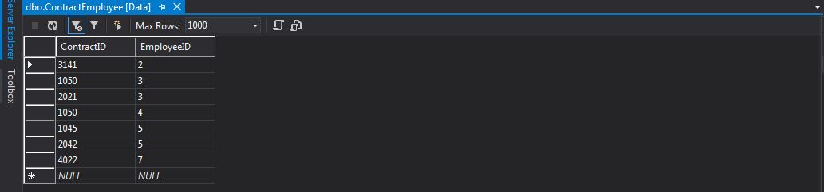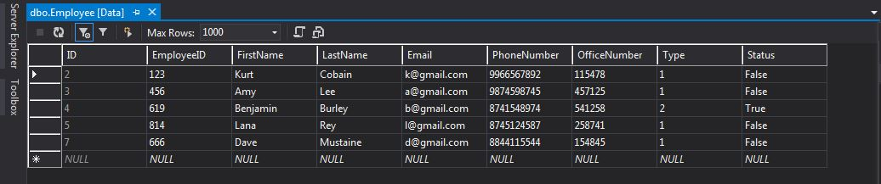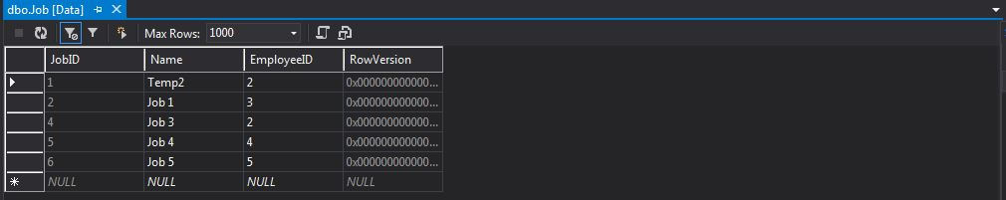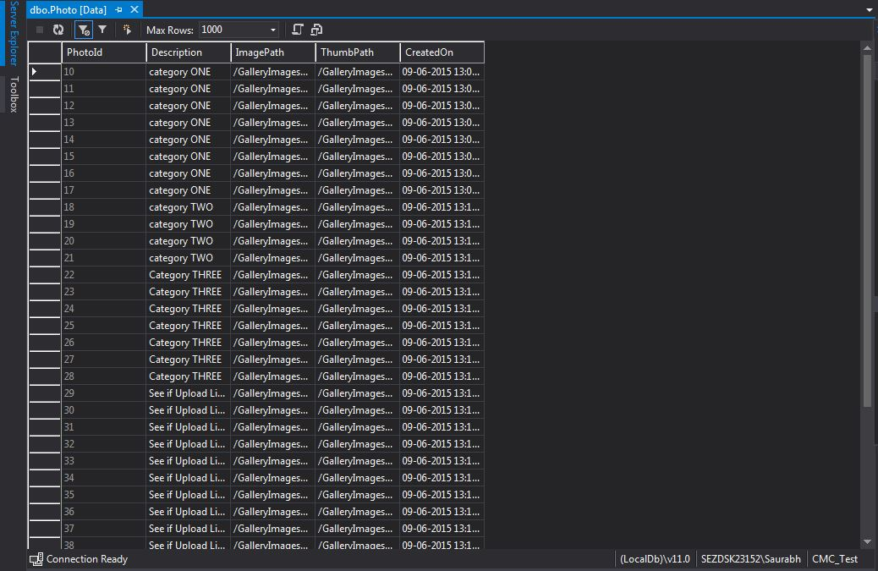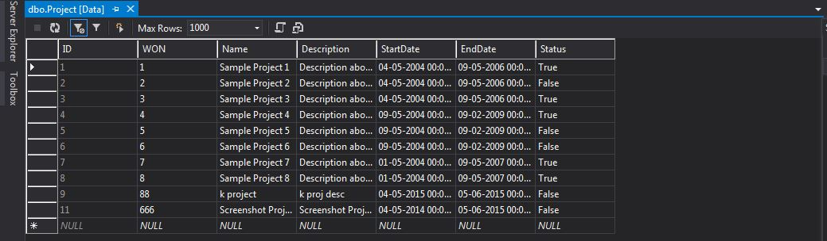

Data stored in the database.

**CONCLUSION**

The web application provides users with a wide range of options . The usr has an option to Create new, edit , delete and view details for project, contract,employee and job. The user is provided with a very friendly interface, hiding all the technical intricacies. The web application is designed and coded in such a way that any further modifications that are needed in the future can be easily implemented without affecting the functionality of the system. This makes this application efficient, convenient and easy to use along with providing maximum user satisfaction which is the key aspect for any developer.

On the whole, this internship was an excellent and rewarding experience. I have gained new knowledge, skills and met many new people. I achieved several of my learning goals. I got insight into professional practice. I learned the different facets of working within a company. Also, this training built professionalism, punctuality and dedication in me. The overall employability has been enhanced and I feel more ready to work in company in the coming times.

On the technical front, I learned about asp.NET and building a web application. I used various technologies and frameworks including bootstrap, HTML,CSS, C#, MVC architecture, Code first approach and Entity Framework , to name a few.Other than the knowledge I gained during this period, it has encouraged me to follow it up even after the training got over.